SECTION 2: INVENTORY & ANALYSIS

Regional and Local Setting
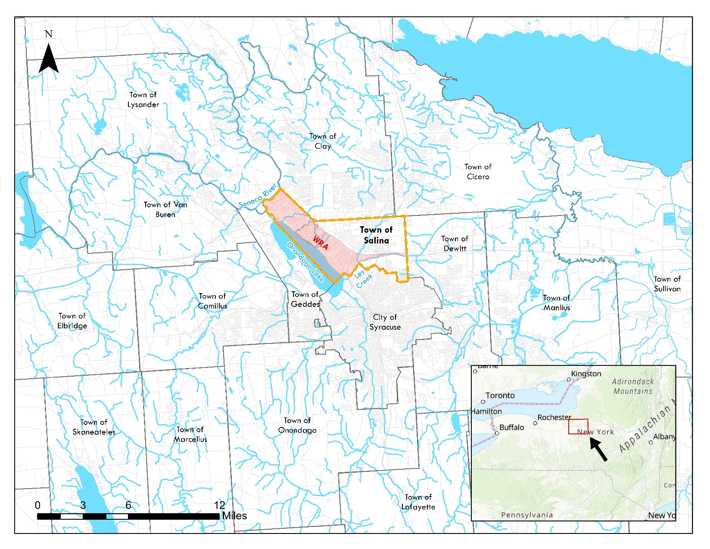
The Town of Salina is located in Onondaga County, New York, bordering the City of Syracuse to the north, 84 miles east of Rochester, 54 miles West of Utica, and 67 miles south of Watertown. The Village of Liverpool falls entirely within the Town of Salina, with its southern boundary along Onondaga Lake. The Town of Salina covers 15.1 square miles, with 13.8 square miles of it on land and 1.3 square miles along the lake shoreline, while the Village of Liverpool covers 0.75 Square miles. Salina has a population of approximately 33,223; this includes Liverpool’s population of 2,242 (2020 Decennial). Salina is bordered by the Town of Clay to the north, the Town of Lysander to the northwest, the Town of Geddes to the west and south, the City of Syracuse to the southeast, and the Town of Dewitt to the east, as shown below in Figure 1 Local and Regional Setting.
Figure 1 Local and Regional Setting

History and Community Characteristics
The inventory and analysis included in this section provide an understanding of current conditions within the Town of Salina and the Village of Liverpool and their Waterfront Revitalization Area (WRA). Early in the LWRP process, the Committee identified topics that were present or a priority in the WRA and eliminated topics that were not present and not a priority. This section will discuss the demographic and physical traits of the Town and Village, and specifically cover subjects such as population, housing, the economy, land use, zoning, property ownership, vacant and abandoned parcels, natural and built resources, and public access and recreation. This section will utilize WRA-specific data where available. An understanding of the Town and Village’s current conditions and identifying issues and opportunities related to the above topics sets the stage for discussion related to proposed policies in Section III and projects in Section IV.

Historical Context
The Skä•noñh Great Law of Peace Center, located along the Onondaga Lake Parkway within the Waterfront Revitalization Area, is a key cultural and educational resource that provides interpretation of the history, values, and living traditions of the Haudenosaunee (Iroquois). The site is owned by Onondaga County and operated by the Onondaga Historical Association (OHA), serving as a destination for residents, visitors, and school groups through exhibits, programming, and cultural events.
The site was developed as a cultural visiting center in the 1990s with a focus on the history of Sainte Marie among the Iroquois, a short-lived French Jesuit mission that existed from approximately 1656 to 1658. As a result, many of the existing structures and interpretive elements on the site reflect this brief period of European presence rather than the much longer and more significant history of the Haudenosaunee people in Central New York. Over time, the mission and focus of the Skä•noñh Center has evolved to more accurately represent and interpret Haudenosaunee culture, history, and contemporary presence. However, the physical layout and built features of the site do not fully reflect this shift, creating a disconnect between the Center’s interpretive goals and the existing site conditions.
In addition to this interpretive mismatch, several physical elements of the site have deteriorated over time. Outbuildings originally constructed to support historical reenactments are no longer actively used for that purpose, and as a result, have fallen into disrepair. Features such as the palisade fencing have degraded and are no longer structurally sound, and elements of the chapel, including a bell, have been damaged or lost. These conditions detract from the overall visitor experience and limit the site’s ability to function as a high-quality cultural destination.
The site’s proximity to active railroad infrastructure also presents safety considerations that affect circulation and access. Additionally, while the site is located within a broader network of waterfront parks and trails, opportunities to integrate nature-based recreation and environmental education are not fully realized.
In the late 1790s, New York State took formal control over the salt springs that existed along the Onondaga Lake, creating a Salt Reservation to manufacture salt. The State mapped the marshlands and uploads, naming them ‘Salina’, and the subsequent village created in the land was also called Salina. When organizing into the Town of Salina, lots of the northwestern corner of Manlius were taken and combined with the Salt Reservation to form the town’s boundary. The original boundary of the town stretched around the Onondaga Lake, which incorporated part of what is now the town of Geddes and the city of Syracuse; however, in the 1840s, Salina was reduced to its present size.
The town's early industry focused on the manufacture of salt from the local salt springs. As the salt industry decreased, other industries, such as raising willows for baskets along with the building and repairing of canal boats, saw considerable activity in the late 19th century.
The Jesuit Well Heritage Site is an important cultural marker in the history of European–Haudenosaunee relations in Central New York but is currently difficult to access and lacks visibility and interpretive amenities.

Demographics
Demographic data was gathered using 2022 5-year American Community Survey (ACS) and 2020 Decennial Census Data.

Population and Age
Both the Village of Liverpool and the Town of Salina have experienced a steady population decline. Salina’s population decreased from 37,386 in 1980 to 33,223 in 2020, an 11% decline. While this decrease is less severe than Liverpool’s 21% decline over the same period, it contrasts with Onondaga County’s overall 3% population increase.
The age cohorts most affected by Salina’s population decline were those 19 and under and those aged 35-54, which saw decreases of 0.4% and 2.1%, respectively, since 2010. Liverpool experienced even steeper declines in these groups, with decreases of 2% and 8%, respectively. Together, these cohorts often represent families with children, indicating a regional shift in household composition.
Meanwhile, the senior population (65+) in Salina grew modestly by 0.7%, while Liverpool saw a significant 9% increase. The 55-64 age cohort grew in both municipalities, with Salina experiencing a modest 0.9% increase compared to Liverpool’s 3% growth.
The most notable difference between the two municipalities was in the 20-34 age group. In Salina, this cohort grew by 4.9%, while in Liverpool, it declined by 3%, suggesting differing trends in younger adult populations between the two communities.

Table 1 Population Change from 1980 to 2020
 | 1980 | 1990 | 2000 | 2010 | 2020 | 1980-2020
Liverpool | 2,849 | 2,624 | 2,505 | 2,347 | 2,242 | -21%
Salina | 37,386 | 35,268 | 33,503 | 33,738 | 33,223 | -11%
Onondaga | 463,920 | 468,973 | 458,336 | 467,026 | 476,516 | 3%
Source: 1980-2020 Decennial Census Data

Chart 1 Change in Age Cohorts, 2010 – 2020 (Source: ACS 5-Year Estimates)
Retaining the 35-55 age cohort is crucial, as this group is typically made up of established professionals who are married, raising families, and homeowners. They are among the most active community members, the most productive in the workforce, and the least likely to relocate. At the same time, the aging population—particularly in Liverpool—is growing. An aging demographic often signals an increased demand for community services, expanded mobility and transportation options, healthcare facilities, and a more diverse housing stock. Addressing these needs will not only support seniors but also help attract young professionals and families, ensuring a sustainable future for Salina and Liverpool.
Chart 2 Town of Salina Age Cohorts (Source: ACS 5-Year Estimates)
Chart 3 Village of Liverpool Age Cohorts (Source: ACS 5-Year Estimates)

Educational Attainment
Educational attainment is a key indicator of income and employment within a community. Among residents aged 25 and older, Salina and Liverpool are generally in line with Onondaga County’s educational attainment levels. At least 90% of residents in all three municipalities have completed high school. Liverpool has a slightly higher share of residents with Associate’s and Bachelor’s degrees compared to the Town and County. Given these comparable education levels, household incomes across the Village, Town, and County are also relatively similar.
Chart 4 Educational Attainment in Salina, Liverpool, and Onondaga County (Source: ACS 5-Year Estimates)

Income
Median household income in the Village of Liverpool, the Town of Salina, and Onondaga County has seen notable growth between 2010 and 2023, reflecting broader economic trends and shifts in the regional job market. All three municipalities experienced an increase in household income, though at varying rates.
In Liverpool, median household income rose from $52,188 in 2010 to $77,629 in 2023, representing a 49% increase. The Town of Salina experienced a 44% increase, with median household income rising from $49,124 to $70,538 over the same period. Onondaga County’s median household income increased 48%, reaching $74,704 in 2023.
While all three areas experienced similar growth rates, Liverpool continues to have the highest median income, likely due to higher property values, a larger share of college-educated residents, and access to employment hubs. Salina, though experiencing slightly lower income growth, remains competitive with regional trends, particularly given its diverse employment base, including healthcare, manufacturing, and waste management industries.
These income gains suggest a strengthening local economy, but they also highlight the need to ensure that housing affordability, infrastructure, and services keep pace with economic changes. As Micron’s chip plant development in Clay is expected to further impact regional employment and wages, continued monitoring of income trends will be essential for long-term planning and economic resilience.
Table 2 Median Household Income from 2010 to 2023
 | Village of Liverpool | Town of Salina | Onondaga County
2010 | $52,188 | $49,124 | $50,426
2023 | $77,629 | $70,538 | $74,704
% Change | +49% | +44% | +48%
Source: 2010 and 2023 ACS 5-Year Estimates

Employment & Industry
In 2021, a total of 16,718 people worked in the Town of Salina; however, only 1,342 of them were residents, while 15,376 commuted into the town for work. Meanwhile, 10,756 Salina residents commuted out of the town for employment. The largest industry sector in Salina is “Waste Management and Remediation,” accounting for 13.2% of jobs, followed by “Manufacturing” and “Health Care and Social Assistance.” Major regional employers include Upstate University Health System, Syracuse University, St. Joseph’s Hospital Health Center, Wegmans, Crouse Hospital, Loretto, Lockheed Martin, and National Grid.
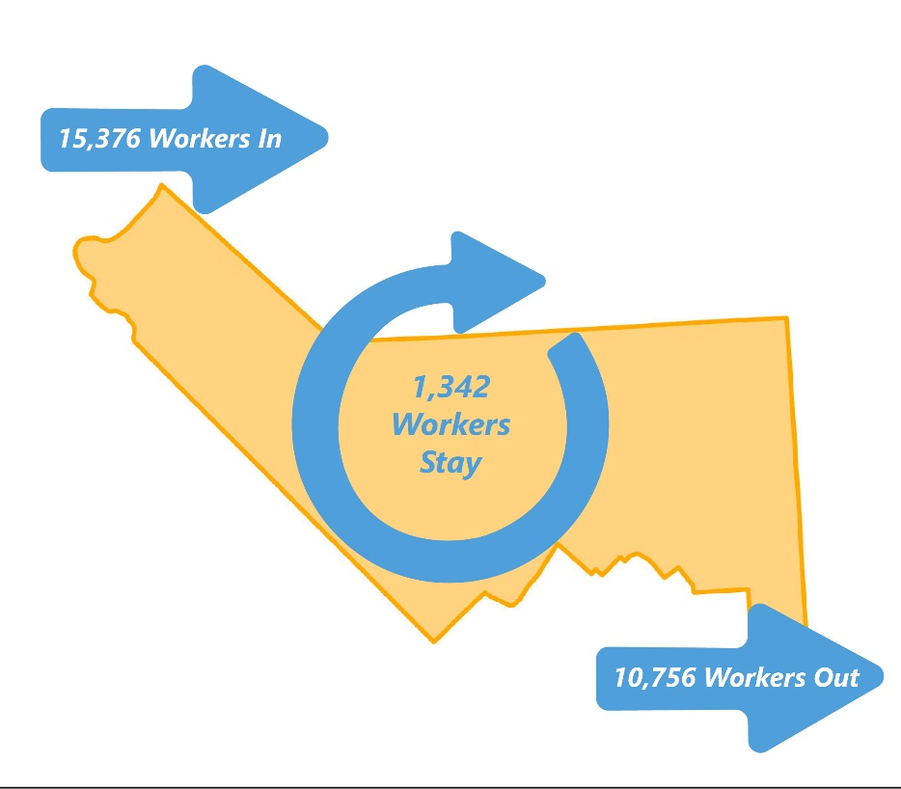
According to the 2020 five-year American Community Survey, the unemployment rate for the civilian labor force in Salina was 2.7%, significantly lower than the national unemployment rate of 5.4% in the same year.
Figure 2 Inflow and Outflow of Workers in the Town of Salina (Source: On The Map, 2021)

Housing
Housing availability, affordability, and condition are critical factors in shaping the quality of life and economic stability of the Town of Salina and the Village of Liverpool. The 2020 Decennial Census provides a snapshot of housing trends in these communities, while the 2023 American Community Survey (ACS) 5-Year Estimates offer additional insights into housing tenure, age of structures, and property values.
As of 2020, the Town of Salina contained 15,752 housing units, while the Village of Liverpool had 1,250 units. The occupied housing rate in Salina was 95%, slightly higher than the 90% rate in Liverpool. Both municipalities have relatively low vacancy rates, with Salina at 5% and Liverpool at 10%, compared to 7% countywide. A stable vacancy rate typically falls between 5-8%, indicating a well-functioning housing market with sufficient turnover to meet demand.

Table 3 Housing Occupancy
 | Village of Liverpool |  | Town of Salina |  | Onondaga County
Total housing units | 1,250 | - | 15,752 | - | 211,343 | -
Occupied housing units | 1,129 | 90% | 14,892 | 95% | 195,566 | 93
Vacant housing units | 121 | 10% | 860 | 5% | 15,777 | 7%
Source: 2020 Decennial Census Data
Housing tenure reflects the balance between owner-occupied and renter-occupied units. In Liverpool, 62% of homes are owner-occupied, while 38% are renter-occupied. The Town of Salina has a higher homeownership rate at 67%, with 33% of units occupied by renters. These figures closely align with Onondaga County’s rates (66% owner-occupied, 34% renter-occupied), suggesting that housing patterns in the WRA are consistent with broader regional trends.
Table 4 Housing Tenure, Age of Housing Stock, and Median Household Value
 | Village of Liverpool | Town of Salina | Onondaga County
Owner-occupied | 62% | 67% | 66%
Renter-occupied | 38% | 33% | 34%
Built prior to 1960 | 72% | 50% | 45%
Median HH Value | $173,900 | $149,200 | $202,400
Source: 2023 ACS 5-Year Estimates
A notable amount of the housing stock in both municipalities is older, which has implications for maintenance, energy efficiency, and potential rehabilitation needs. 72% of homes in Liverpool and 50% in Salina were built before 1960, compared to 45% countywide. Older homes often require more frequent repairs and renovations, and if not properly maintained, they can contribute to neighborhood decline. Given the high percentage of aging housing stock, there may be a need for enhanced code enforcement, targeted rehabilitation programs, and incentives for property maintenance and modernization.
Housing values vary across the WRA, with Liverpool having a higher median home value of $173,900, compared to $149,200 in Salina and $202,400 in Onondaga County. Several factors may contribute to this discrepancy:
- Proximity to the Waterfront: Liverpool’s location along Onondaga Lake may increase property values due to scenic views and access to waterfront amenities.
- Neighborhood Character: The Village of Liverpool has a more compact, walkable environment with a traditional downtown, making it attractive to buyers looking for a village setting.
- Housing Stock and Condition: The Town of Salina contains a mix of residential neighborhoods, some of which may have lower property values.
- Market Demand and Development Patterns: As a suburban area, Salina has more diverse housing types, including single-family homes, multi-family residences, and apartments. This variation in housing stock may contribute to differences in median values.
With the expected population and employment growth in the region, particularly due to the Micron chip plant development in the Town of Clay, Salina and Liverpool may experience increased housing demand. Expanding middle housing options (such as duplexes, triplexes, townhomes, and courtyard apartments) could provide more affordable housing choices while maintaining the existing neighborhood character.
Additionally, infill development on underutilized or vacant properties could help increase the housing supply, particularly in areas with access to public amenities and transportation. Ensuring that new development aligns with the community’s vision for sustainable and inclusive growth will be essential in balancing housing needs with neighborhood preservation.

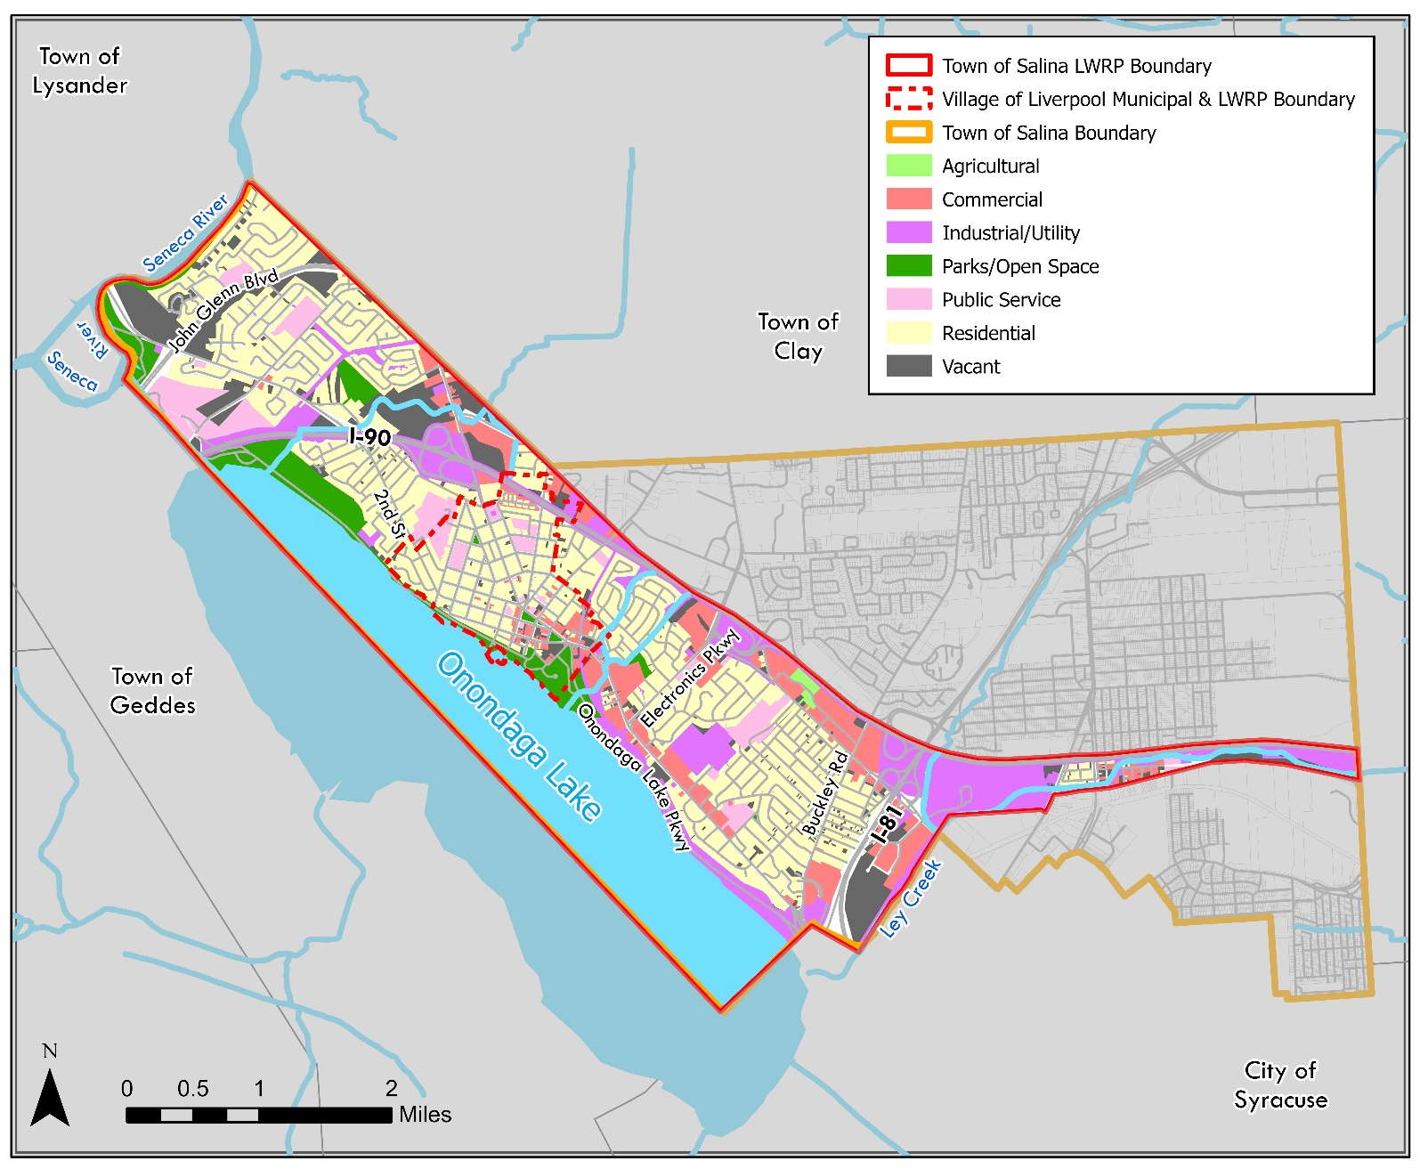
Existing Land Use
Figure 3 Existing Land Use

The existing land use within the Waterfront Revitalization Areas is presented in Figure 3. The WRAs include a variety of land uses, including the commercial corridor along Old Liverpool Rd/Oswego St, and recreational and residential spaces.

Residential
Residential uses are the largest portion of land in the WRAs. Residences are concentrated within the center area of the WRAs, with a smaller cluster of homes between US Route 11 and Lemoyne Ave. A vast majority of both Salina’s (81%) and Liverpool’s ((91%) housing stock was built in 1960 or earlier.

Commercial
Commercial properties within the WRA generally run along I-90 and Old Liverpool Rd/Oswego St. Businesses in these areas include hotels and motels, restaurants, retail, tattoo shops, healthcare, pet care and automotive repair.
Recreation & Entertainment
Recreation parcels are concentrated along the southern portion of the WRA located adjacent to the Onondaga Lake shoreline – this includes the Onondaga Lake Park what has amenities such as a playground, skate park, public dock, visitor center and access to the Restoration Way Trail. The Onondaga Yacht Club is also located directly to the west of the Park. To the east of the park is the Butterfly Garden of Hope memorial and the Skä•noñh Great Law of Peace Center Museum.
Public Services
The Salina Town Hall site offers a community destination and strengthens the connection between civic life and the waterfront. The Town of Salina recently completed construction of a pavilion and scenic overlook of Onondaga Lake at Town Hall.

Zoning
The Town of Salina Zoning Law was most recently amended in its entirety in 1998, replacing the 1969 Zoning Law. In 2023, Onondaga County Department of Planning prepared a draft zoning district and overlay map for the Town of Salina, which is shown below in Figure 4.
There are a total of 16 zoning districts: R-1 One-Family Residential District; R-1A Districts: One-Family Residential District; R-2 One- and Two-Family Residential District; R-3 One- and Two-Family Residential District; R-4 Multiple-Family Residential District; R-5 Multiple-Family Residential/Commercial District; R-O Open-Land District; R-5 Multiple-Family Residential/Commercial District; C-1 Neighborhood Commercial District; C-2 Highway Commercial District; C-3 Planned Commercial District; O-1 Professional Office District; O-2 Office and Light Industrial Park District; I-1 Industrial District; OL-1 Motor Vehicle Service Facilities Overlay District; RROD Repurposing and Reuse Overlay District.
R-1 One-Family Residential District: The purpose and intent of this district is to provide areas where the living environment associated with one-family residential development is encouraged and preserved.
R-1A One-Family Residential District: The purpose and intent of this district is to provide areas which permit one-family dwellings on existing smaller-sized lots and at a greater density than permitted in other one-family districts, while still protecting the amenities and characteristics associated with low-density residential development.
R-2 One- and Two-Family Residential District: The purpose and intent of this district is to provide areas where the living environment associated with one- and two-family residential development is encouraged and preserved.
R-3 One- and Two-Family Residential District: The purpose and intent of this district is to provide areas which permit one- and two-family dwellings on existing smaller-sized lots and at a greater density than permitted in other one- and two-family districts, while still protecting the amenities and characteristics associated with low-density residential development.
R-4 Multiple-Family Residential District: The purpose and intent of this district is to provide areas where the living environment associated with multiple-dwelling-unit development is encouraged and preserved.
R-5 Multiple-Family Residential/Commercial District: The intent of this district is to provide a similar use as the R-4 District but to permit limited commercial uses on the first floor of a multiple dwelling erected in an appropriate location for this type of use
R-O Open-Land District: The intent of this district is to maintain a quality of environment to provide for leisure, recreational areas, facilities, baseball diamonds, walking trails, bicycle trails, swimming pools, recreation buildings and all other uses related directly to the statement of intention hereinabove set forth and to permit a conservative balance of R-1 District uses compatible with these overall objectives.
C-1 Neighborhood Commercial District: The intent of this district is to provide areas, in or adjacent to residential neighborhoods, for commercial uses which provide essential convenience goods and services to the residents thereof.
C-2 Highway Commercial District: The intent of this district is to provide areas, on highways designed to handle large traffic volumes, for commercial uses which primarily serve the motoring public and which function rather independently of each other.
C-3 Planned Commercial District: The intent of this district is to provide areas, on highways designed to handle large traffic volumes, for well-planned and -designed commercial uses which primarily serve the motoring public and which are generally compatible with each other.
O-1 Professional Office District: The intent of this district is to promote districts containing only office uses in areas where the additional uses permitted in other office and light industrial districts might be detrimental to adjoining uses areas.
O-2 Office and Light Industrial Park District: The intent of this district is to provide areas, near or adjacent to highways designed to handle large traffic volumes, where the quality of environment associated with well-planned and -designed office and light industrial parks is encouraged and preserved.
I-1 Industrial District: The intent of this district is to provide areas, near or adjacent to highways designed to handle large traffic volumes, for industrial, heavy commercial and other uses which are not generally compatible with the uses permitted in other districts or which are not otherwise permitted in the code.
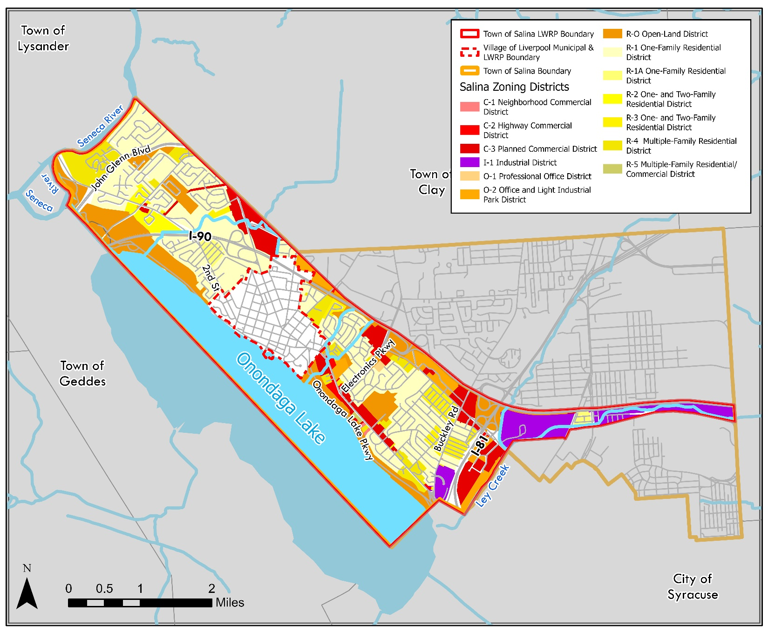
OL-1 Motor Vehicle Service Facilities Overlay District: The Town recognizes that motor vehicle service and repair as defined in this chapter are an essential element of the community that must be readily available to the driving public and are beneficial to the safety and welfare of its citizens. The purpose of the Motor Vehicle Service Facilities Overlay District is to ensure that these facilities are located in areas that are readily available and in general harmony with the adjacent neighborhood or district.
Figure 4 Town of Salina Zoning Map

Salina is largely zoned for Residential Uses, with Planned Commercial Districts and Highway Commercial Districts located along Old Liverpool Road and 7th North Street. The Town’s Industrial District generally resides in the eastern portion of the WRA, with it surrounding Ley Creek as it flows through the boundary’s eastern ‘tail’.
The Village of Liverpool Zoning Law was most recently amended in its entirety in 2008, replacing the 1987 Zoning Law. There are a total of 11 zoning districts: R-1 Single-Family Residential District; R-2 Two-Family Residential District; R-3 Multiple-Family Residential District; B-1 Lakeside Business District; B-2 Village Center Business District; B-3 Oswego Street Business District; B-4 General Business District; LI-BP Limited Industrial Business Park; OL Open Land District; PUD Planned Unit Development Overlay Districts; FMD Floodplain Management District.
R-1 Single-Family Residential District: The intent of this district is to promote and preserve the integrity and character of the R-1 District as a single-family residential neighborhood. The character of the R-1 District is exemplified by its historic homes located under shady groves of mature street trees that offer a parklike neighborhood setting.
R-2 Two-Family Residential District: The intent of this district is to promote and preserve the integrity and character of the R-2 District as a single- and two-family residential neighborhood. The character of the R-2 District is exemplified by its historic homes located under shady groves of mature street trees that offer a parklike neighborhood setting.
R-3 Multiple-Family Residential District: The intent of this district is to promote and preserve the integrity and character of the R-3 District as a high-density residential neighborhood. The R-3 District should afford a greater variety of housing options for a variety of lifestyles, while maintaining a higher population density compatible with and supportive of neighboring business districts.
B-1 Lakeside Business District: The intent of this district is to promote mixed-use development to create a compact, walkable, pedestrian-friendly, mixed-use environment built to the scale of the pedestrian in order to promote greater pedestrian activity along buildings fronting the street, public parks and the waterfront promenade along Onondaga Lake.
B-2 Village Center Business District: The intent of this district is to complement the mixed-use Lakeside Business District in use and design while providing greater flexibility in building design. As such, mixed-use buildings are encouraged but not mandated. Single-use, single-occupancy buildings are permitted, but consistent in site layout to adjoining uses to encourage an active, pedestrian friendly shopping and family-oriented entertainment environment.
B-3 Oswego Street Business District: The intent of this district is to complement other mixed-use business districts in use and design through building and site design. As such, mixed-use buildings are encouraged and will serve as a compatible buffer between major roadways and single-use residential neighborhoods. Site layout is similar to the B-1 and B-2 Districts and thus encourages an active, pedestrian-friendly environment.
B-4 General Business District: The intent of this district is to complement the mixed-use business districts in use and design while serving as a gateway into Liverpool from the Town of Salina. Development patterns are less intense and may consist of single-use attached or detached structures. The B-4 District serves as a destination allowing for uses, services and products that are more easily transported and accessible by private automobiles instead of pedestrian traffic.
LI-BP Limited Industrial Business Park: The intent of this district is to complement the business districts including the mixed-use business districts in use and design while providing greater flexibility in building and site design. As such, mixed-use buildings are encouraged but not mandated. Single-use, single-occupancy buildings are permitted, but shall follow similar site layout characteristics to mixed-use layout to encourage an active, pedestrian-friendly employment center.
OL Open Land District: The intent of this district is to ensure the provision of open space and recreation areas for residents and visitors. Recreational facilities and amenities promote pedestrian activity and serve all age groups.
PUD Planned Unit Development Overlay Districts: The intent of this district is to provide flexible land use regulations so that business districts, including and most especially mixed-use business districts, and the light industrial district can be developed within the Village as a fully functional, well-planned district with a critical mass of self-supporting, sustainable development designed consistent with the vision established within the Village of Liverpool Comprehensive Plan 2025 and the corresponding Downtown Redevelopment Plan
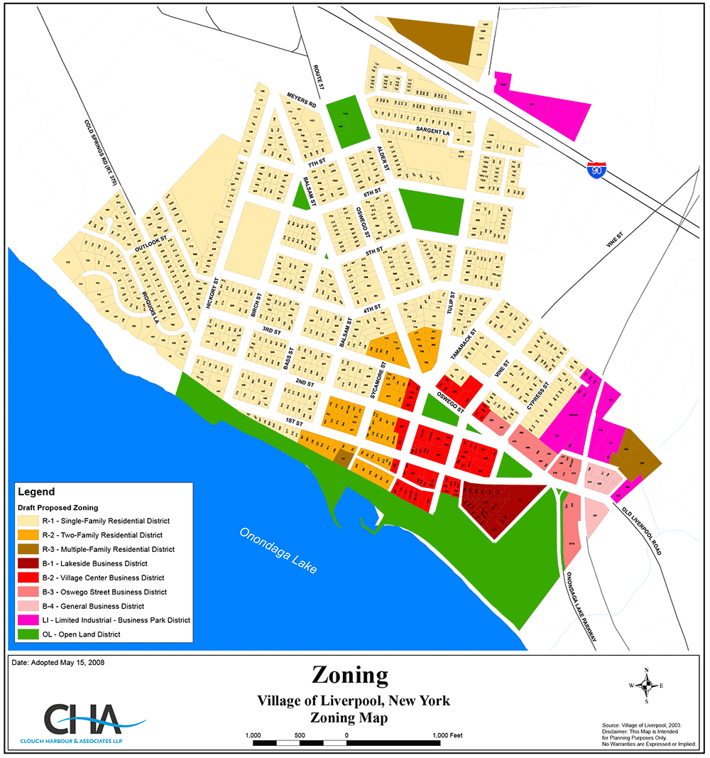
Figure 5 Village of Liverpool Zoning Map

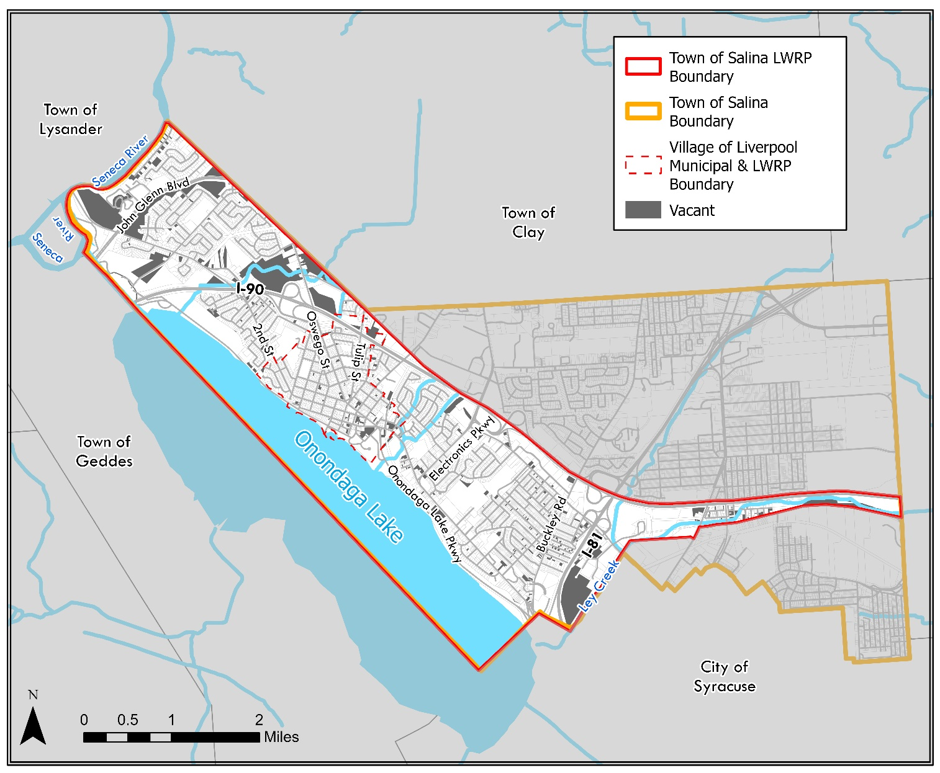
Vacant, Abandoned, and Underutilized Sites
Figure 6 Vacant, Abandoned, and Underutilized Sites Map

Vacant parcels are the second most prevalent land use in the Salina LWRP area, accounting for 480 parcels or 8.8% of the total land area (384 acres). 69 of the parcels (20 acres) are located within the Liverpool WRA, while the reside are in the Salina WRA. As shown in Figure 5, the vacant parcels are spread throughout the area, with larger vacant parcel lots found on both the northern and southern areas of the Salina WRA.
The WRAs include a mix of fully developed areas and properties that are vacant or underutilized, presenting opportunities for redevelopment. While the overall vacancy rate for residential properties in Salina and Liverpool remains stable at around 6-7%, there are key commercial and industrial properties that have been identified as underutilized.
Several parcels within the WRAs, particularly those with former industrial or commercial uses, may be suitable for adaptive reuse or infill development. The economic analysis highlights the need for strategic reinvestment in commercial corridors and mixed-use development, which could repurpose underutilized properties to better align with current market demand. Additionally, the presence of older housing stock suggests that some residential properties may be at risk of becoming blighted if not maintained or rehabilitated.
Figure 7 The 'Gormel' Block
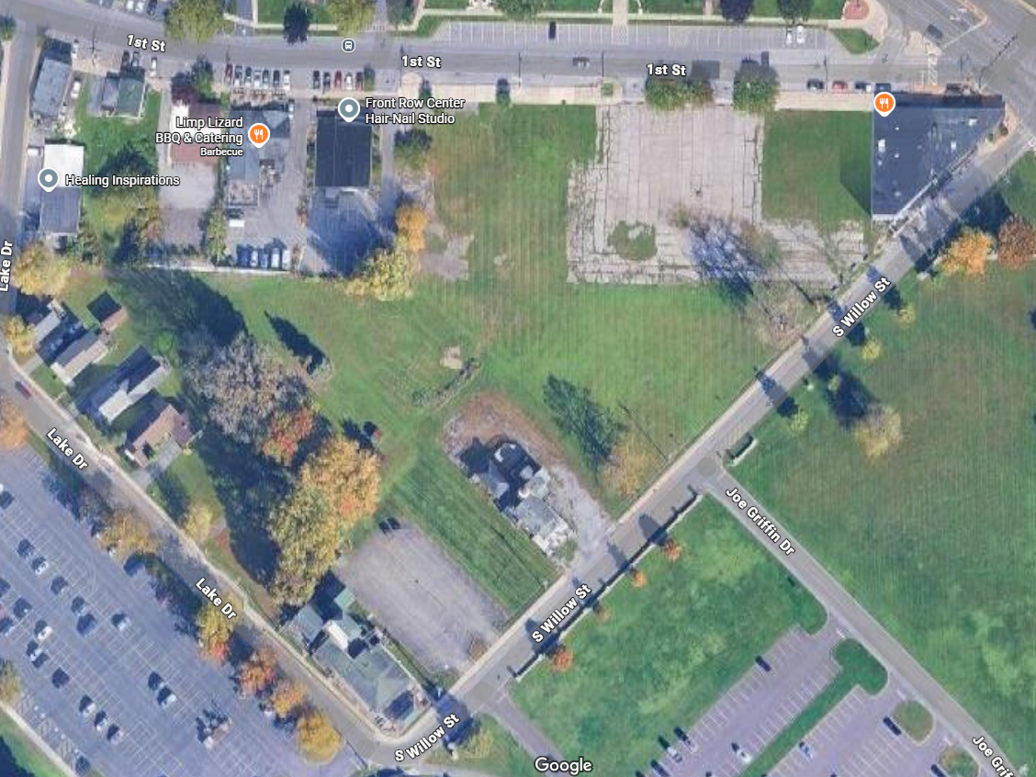
The block of Lake Dr – 1st St – S Willow Street (also referred to as the Gormel Block) is an underutilized site in Liverpool with large potential for future redevelopment. Being located directly adjacent to the Onondaga Lake Park and in the heart of Liverpool’s downtown makes it a highly desirable site for a focused development approach that supports the existing community character. Onondaga Lake Park and its accompanying trails along the Seneca Riverfront generate a lot of daily users, which can be leveraged to support a wide variety of business uses. Cooperation with local developers to guide the redevelopment of this site is critical to ensuring that investments into the site will be in line with the community’s vision.
Moving forward, identifying specific vacant or underutilized parcels and assessing their redevelopment potential will be critical for shaping future land use strategies in Section IV.

Land Ownership
The Onondaga Lake waterfront within the boundaries of the Local Waterfront Revitalization Areas (WRA) is entirely under public ownership, managed by Onondaga County. This ownership structure provides opportunities for collaboration between the Village of Liverpool, the Town of Salina, and Onondaga County. These partnerships can support projects that enhance waterfront access, expand recreational opportunities, and protect and restore the area's natural resources.
Public ownership also ensures the potential for coordinated development strategies that align with the goals of the Local Waterfront Revitalization Program (LWRP). Such efforts may include improving public access points, preserving ecologically sensitive areas, and implementing infrastructure upgrades to support sustainable recreation and conservation initiatives.
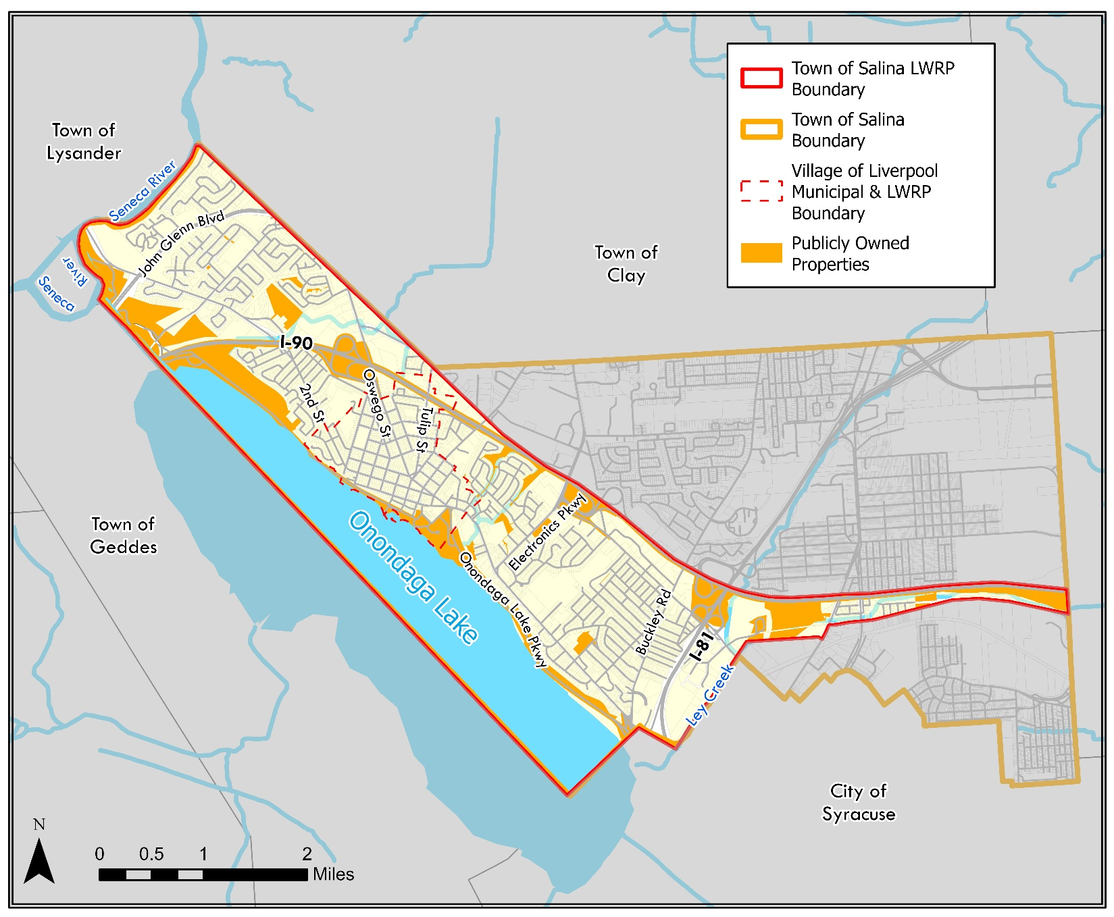
Figure 8 Land Ownership Map

Public Access and Recreation

General Recreation
The Waterfront Revitalization Area (WRA) offers a diverse range of recreational opportunities that attract residents and visitors year-round. Anchored by Onondaga Lake Park, the WRA provides access to a variety of outdoor activities, scenic trails, and family-friendly amenities, making it one of the region’s principal waterfront destinations.
Onondaga Lake Park and its northern extension, Willow Bay Park, serve as key recreational hubs along the waterfront. These parks feature expansive green spaces, picnic areas, and access to Onondaga Lake, offering opportunities for passive and active recreation. Within Onondaga Lake Park, the Wegmans Playground provides a safe and engaging play area for children, while the Onondaga Lake Park Skate Park caters to skateboarders and BMX riders. For sports enthusiasts, the park includes baseball and softball fields, as well as newly established pickleball courts, which have grown in popularity among residents of all ages.
Duerr Park is a quiet neighborhood park featuring a playground, basketball court, open green spaces, and walking paths shaded by trees. It offers picnic tables and benches, making it a pleasant spot for families and locals to relax or enjoy casual outdoor activities. The park is appreciated for its peaceful atmosphere and community-friendly vibe. Despite its relative proximity to the lake the park does not currently connect with Onondaga Lake.
Within the Village of Liverpool, Lamb Park, Johnson Park, Washington Park and Carriage park offer small but significant green spaces for residents and visitors alike. Memorial Park, historically known as Lamb Park, is a quiet reflective space that carries historic and cultural importance in the Village. However, the historic amenities in Lamb Park, including the canon, need refurbishment. Johnson Park is a central gathering space and is well-known for its gazebo, fountain, picnic area and stage that hosts live music and community programming such as the “Liverpool Is The Place” summer concert series. Washington Park offers walking paths, playgrounds, picnic areas, gardens, and open fields that support family outings, passive recreation, and community events. Lastly, at the intersection of Tulip Street, Tamarack Street and Park Street there is a small triangular greenspace informally known as Carriage Park. This space covers 23,000 square feet and offers a shaded, quiet environment within a residential neighborhood. These Village parks are popular and well-loved and thus have amenities that are experiencing wear and age.
Cyclists and runners can take advantage of the miles of protected, asphalt paths that traverse the WRA, including the scenic Onondaga Lake Parkway Trail and Restoration Way Trail. These well-maintained multi-use trails provide a continuous connection along the lakefront, supporting walking, jogging, biking, and rollerblading while offering stunning views of the waterfront. Additionally, Syracuse Cuse Cycle, a bike rental service available within the park, enhances accessibility for visitors who may not have their own bicycles.
Willow Bay Picnic Area serves as a gathering spot for families and community groups, featuring picnic shelters, open lawn spaces, and access to the lake’s shoreline. Building on these recreational opportunities will be key to further enhancing public access to the waterfront, supporting economic development, and reinforcing the WRA’s role as a regional destination for outdoor recreation.
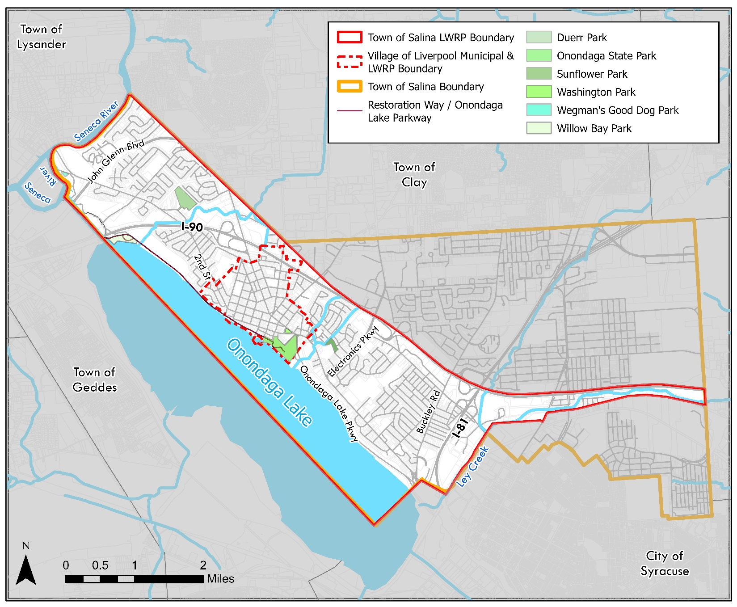
Figure 9 Parks and Recreation

Public Access
The Village of Liverpool contains a variety of physical connections to the waterfront and Onondaga County parklands, with several streets functioning as key access points between residential areas and public recreational spaces. Within the Village of Liverpool, Sycamore Street, Tulip Street, and Vine Street provide pedestrian routes to both the Restoration Way Trail and Onondaga Lake Park. Currently, Sycamore Street and Tulip Street lack wayfinding signage and have limited pedestrian accommodations, which may affect ease of navigation and comfort for users traveling on foot.
Birch Street also provides a direct route to Onondaga Lake Parkway; however, its pedestrian and bicycle connections are not clearly defined or formalized, potentially limiting its use as a safe, multimodal access point.
To the east, South Willow Street functions as a primary vehicular entrance to Onondaga Lake Park. This corridor connects neighborhoods to park amenities and waterfront access; however, current infrastructure presents limited features supporting coordinated pedestrian, bicycle, and vehicle movement.
As of April 2025, the marina adjacent to the park is undergoing an expansion of its boat slips, which may result in increased usage of surrounding access points and support facilities. Additionally, the adjacent park space includes ballfields and pickleball courts that experience regular use; the availability of these facilities may be a consideration as use of the waterfront increases.
Although Onondaga Lake already hosts a network of trails, such as the East Shore Recreation Trail, West Shore Trail, and Shoreline Walking Trail, there remains a gap in the trail system along the Onondaga Lake Parkway in the Town of Salina that prevents a continuous loop around the lake. Private land ownership along the Seneca River contributes to this gap. Along the Onondaga Lake Parkway, three locations connect the roadway to the Restoration Way Trail, forming natural loops suitable for recreational activity. These locations lack any existing fitness or activity stations, which could otherwise support trail-based recreation.
The Cold Springs Road neighborhood, located north of the parkway, is separated from the waterfront by forested land and marsh areas. While there is no existing connection across this area, a route such as a wetlands boardwalk could provide access while limiting environmental disruption, though no such facility currently exists between Cleveland Avenue and the Parkway.
The Sunflower Neighborhood currently has limited access to the waterfront, with only two automotive entry points along Electronics Parkway. This lack of pedestrian connectivity restricts mobility options for residents and limits safe, non-motorized access to surrounding areas and the waterfront.
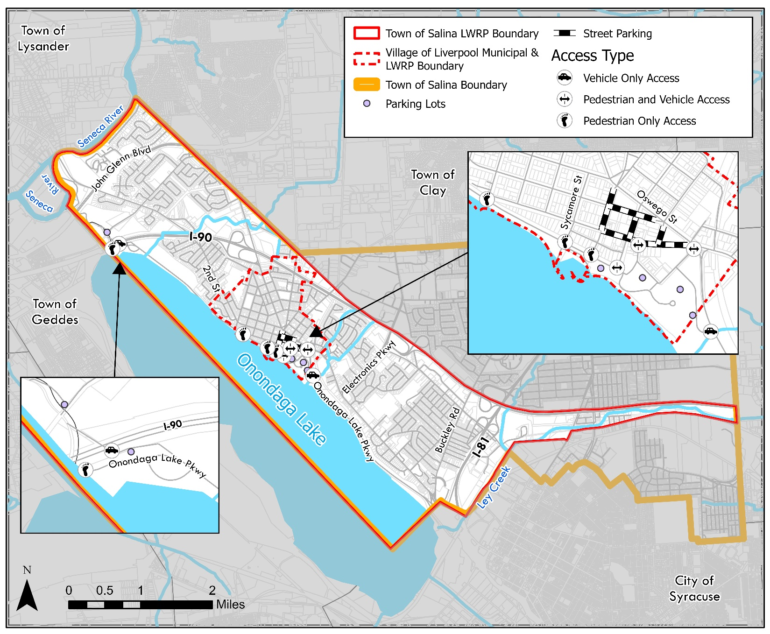
Figure 10 Public Access and Parking

Water Uses
One of the primary goals of an LWRP is to leverage waterways as both recreational and economic assets, while also balancing the diverse needs of all residents who share these resources. Access to Onondaga Lake is somewhat constrained by Onondaga Lake Parkway and the rail line along the southeastern shoreline; however, the northwestern shoreline features the Restoration Way Riverwalk, which provides a scenic pathway connecting Willow Bay Picnic Area to Onondaga Lake Park. Onondaga Lake was a popular tourist destination in the early 19th century, but industrial development and population growth led to pollution from sewage and industrial discharges, severely affecting water quality. For a time in the mid-19th century, the lake was closed to swimming and fishing. However, ongoing pollution control efforts have significantly improved water quality, and fishing was reintroduced in 1986. Both local and federal efforts to remediate the lake's pollution are ongoing. Onondaga Lake is now used for fishing and motorized boating.

Boating
The Onondaga Lake Park Marina and Boat Launch and the Onondaga Yacht Club are recreational assets. The Onondaga Yacht Club hosts a variety of activities, including for learning, recreational sailing or racing. The Yacht Club also maintains an inventory of canoes and kayaks for its members, along with a smaller dock for boat launching. Besides the dock from the Yacht Club, there are no official kayak or canoes launches in the WRA. Additionally, along the Seneca River portion of the LWRP boundary is a large rental community and a privately owned marina that provides docking facilities, access to the river, and a boat launch. Several of the docks are aging, dredging is needed to improve navigability and safety, and the boat launch and shoreline access are in poor condition.

Fishing
The Onondaga Lake has separate water classifications for its northern and southern segments, as determined by the New York State Department of Environmental Conservation (NY DEC). Its northern segment has the water quality “B” classification. The best uses of Class B waters are primary and secondary contact recreation and fishing, but it should not be used for drinking or food processing purposes. Primary water contact recreation includes activities that immerse the body in water, such as swimming, whereas secondary water contact are activities without full immersion, such as boating. The southern lake segments has the water quality “C” classification. The best use of Class C waters is fishing; although suitable for primary and secondary water contact recreation, other factors may limit its use for these purposes.
The lake has a number of fish species present, the most popular gamefish are largemouth and smallmouth bass. Largemouth bass grow large in the lake with fish commonly caught in the 17 to 19-inch range. Common carp are numerous, grow large, and can be found throughout the lake. Other fish species include tiger musky, northern pike, walleye, pumpkinseed sunfish, bluegill, black crappie, rock bass, yellow perch, white perch, channel catfish, brown bullhead, bowfin, freshwater drum, longnose gar, round goby, and gizzard shad.

Automobile
Onondaga Lake Park and Willow Bay Park each offer two public parking lots providing convenient access to recreational amenities, while the Onondaga Lake Park Marina features a dedicated parking lot that requires a permit for use. In addition to these facilities, the Village of Liverpool has multiple public and private parking lots, as well as an abundance of on-street parking options, accommodating both residents and visitors.
However, signage directing drivers to available parking is limited and, in some cases, confusing, particularly along key roadways such as Old Liverpool Road, Onondaga Lake Parkway, and Oswego Street. The lack of clear and visible signage has been identified as a challenge, potentially leading to confusion for visitors unfamiliar with the area. Improved wayfinding signage that would enhance accessibility by guiding drivers to designated parking areas, reducing congestion, and supporting local businesses and waterfront attractions was identified as a need. Additionally, the intersection where Old Liverpool Road, Oswego Street, 1st Street, South Willow Street, and Onondaga Lake Parkway converge leading to Onondaga Lake Park is complex, unsafe and also lacks proper wayfinding signage.

Infrastructure

Water
Salina’s water is provided by the Onondaga County Water Authority, which oversees the distribution of water to Onondaga, Madison, Oswego, Oneida, and Cayuga County residents. OCWA water originates from Otsico Lake, Lake Ontario, and/or Skaneateles Lake, depending on the geographic location of the clients and changes in seasonal demand – water delivered to Salina comes from Otisco Lake. In 2023, OCW supplied, on average, 36.33 million gallons per day to approximately 97,600 residential accounts located throughout its operation area.

Sewer
The Onondaga County Department of Water Environment Protection’s Metro Syracuse Wastewater Treatment Plan is responsible for the collection of sewer in Salina and Liverpool. The plant is the largest of Onondaga Count’s wastewater treatments plants, treating 84 million gallons of wastewater per day.

Refuse Collection
Syracuse Haulers oversees the collection of curbside solid waste and recycling services once a week.

Utilities
Electrical and communication utilities within portions of the Waterfront Revitalization Area, particularly within the Village of Liverpool’s downtown corridor, are currently located above ground on utility poles. In areas such as First Street, overhead utilities contribute visual clutter within the Village’s primary commercial and social corridor and may limit opportunities for enhanced streetscape and pedestrian improvements.

Transportation Systems

Roadways
Forming the northern border of the WRA, I-90 (New York State Thruway) provides vital east-west regional access. Exit 37 connects directly to Electronics Parkway, enabling seamless access to the central parts of Salina and Liverpool. As a toll highway, I-90 supports both passenger and commercial traffic, playing a critical role in the regional transportation network.
I-81 runs north-south through the eastern portion of the WRA, it is a key regional corridor that connects Syracuse with surrounding areas, including Watertown to the north and Binghamton to the south. Access points within the WRA facilitate connectivity to major arterial routes such as NYS Route 370 and Electronics Parkway, ensuring efficient movement across the region.
NYS Route 370 transitions through several identities within the WRA:
- Onondaga Lake Parkway: A scenic four-lane expressway along the lake’s northeastern shore, offering panoramic views of Onondaga Lake. It bans commercial vehicles due to a low railroad overpass.
- Second Street: Upon entering the Village of Liverpool, it becomes Second Street, a primary road for local businesses and pedestrian activity.
- Cold Springs Road: Beyond Liverpool, the route supports medium-density residential areas and provides access to neighborhoods in western portions of the WRA.
County Route 57 (Oswego Street) begins at the convergence of Oswego Street, Old Liverpool Road, and Onondaga Lake Parkway in Liverpool. As it extends northward, Oswego Street shifts from a residential main street to a commercial thoroughfare serving as a key arterial road in Liverpool.
Electronics Parkway is in the central location of the WRA, this arterial road connects I-90 to residential areas and commercial hubs. Hosting businesses such as hotels, restaurants, and employers, Electronics Parkway is essential for economic activity. Its direct connection to I-90 facilitates accessibility for both local and regional traffic.
Buckley Road is an arterial route in eastern Salina, Buckley Road serves residential neighborhoods and subdivisions. Its strategic position provides local connectivity and supports access to other regional routes. Old Liverpool Road is a heavily trafficked corridor within Salina, Old Liverpool Road links residential areas to commercial zones and serves as a connector to Oswego Street and Onondaga Lake Parkway. Vine Street and Tulip Street are high-volume local roads offering access to Liverpool’s neighborhoods and connect to significant routes within the WRA, including Second Street. They support residential traffic while providing linkages to the waterfront area.
All of these roadways play a critical role in facilitating regional and local connectivity, supporting economic activity, and integrating transportation within the WRA’s revitalization efforts.

Air
The Syracuse Hancock International Airport straddles the eastern part of the Town of Salina and the northwest portion of the Town of Dewitt. Other smaller airports in the region include the Oswego County Airport, Marcellus Airport, Whitford’s Airport (B16), Finger Lakes Regional Airport, and Griffiss International Airport-RME.

Rails
CSX Transportation has a cargo rail line that runs through the WRA. The only Onondaga Lake waterfront parcel that is not owned by Onondaga County is owned by CSX Transportation, Inc and located at the southeast portion of the WRA. CSX serves the DeWitt Rail Yard, located in East Syracuse. CSX Transportation typically handles metals, forest products, chemicals, grain, fuel, automobiles, and other local commodities.
The nearest Amtrak station is the Syracuse Walsh Regional Transportation Center located 4 miles south of the town in the City of Syracuse.

Busing
Central Public transit provides transportation to Onondaga, Cayuga, Oswego, and Oneida Counties, operating daily. The Nearest Greyhound Bus Station is located in Syracuse. The Greyhound Bus Lines offers extensive nationwide and Canadian Travel options. Adirondack.

Pedestrian & Bicycle Connections
Salina's suburban landscape features a limited sidewalk network, with ongoing efforts to enhance pedestrian infrastructure. New sidewalks are being constructed along Old Liverpool Road, and while most of the village is equipped with sidewalks, some residential streets near the village border lack them. The town's waterfront area, largely unimpeded by the railroad line or major roadways, is entirely publicly owned and integrated into the town's park system. This includes the Willow Bay Picnic Area, the Restoration Way Riverwalk, and the Onondaga Lake Parkway. Some areas are impeded by the CSX Railroad and require an alternative solution for pedestrian and bicycle crossing.
Onondaga Lake Park, a central feature of the town's recreational offerings, boasts an extensive trail system catering to both pedestrians and cyclists. The East Shore Recreation Trail, over two and a half miles long and twenty feet wide, is designated for in-line skating and bicycling. During peak season (April to October), pedestrian use is permitted only if it does not impede wheeled users. Adjacent to it, the Shoreline Walking Trail, a two-mile path along the eastern lake shore, is reserved for walkers and runners, with distance markers to assist users in tracking their mileage. The West Shore Trail, extending 4.5 miles along the western shore of Onondaga Lake, is suitable for bicyclists, walkers, runners, and nature enthusiasts. This trail meanders through woodlands and open areas, offering several shelters and benches along the way.
These trails are part of a broader initiative to improve transportation systems in the region. The Syracuse Metropolitan Transportation Council (SMTC) has completed numerous bicycle and pedestrian planning activities and studies that cover site-specific improvements, corridors, neighborhoods, municipalities, and the overall planning area. These efforts aim to make streets safer for pedestrians and cyclists by giving them priority and slowing down vehicle speeds.
The Village of Liverpool’s downtown and waterfront are great assets but currently lack adequate pedestrian and bicycle infrastructure. While Sycamore Street, Vine Street, and Tulip Street serve as the primary corridors linking downtown Liverpool to Onondaga Lake, these streets lack the pedestrian, bicycle, and streetscape amenities.

Natural Resources

Flood Zone
A flood zone is the level of land along the course of a water body that is prone to flooding. To mitigate the effects of a flood during times of high water levels (after a large rain or snowmelt), the Federal Emergency Management Agency controls and protects the areas located within these federally designated flood zones. In the northeastern border of the Town, the 100-year floodplain travels along John Glenn Blvd past where it intersects with Kings Park Dr. Traveling southeast, the floodplain’s landward infiltration recedes as it travels towards the boundaries of Liverpool. At the intersection of South Willow Street and Lake Dr, the floodplain area begins to advance deeper into Liverpool, reaching the intersection of Salina St and Peral St.
The 100-year floodplain is also located along an open water culvert that runs slightly to the east of Liverpool, which travels from the municipal boundary of Salina to Onondaga Lake. The 100-year flood plain stays relatively close to the shoreline of Onondaga Lake as it continues traveling southeast. As it reaches the southwestern boundary of the WRA the floodplain then follows the flow path of both Ley Creek and Beartrap Creek.
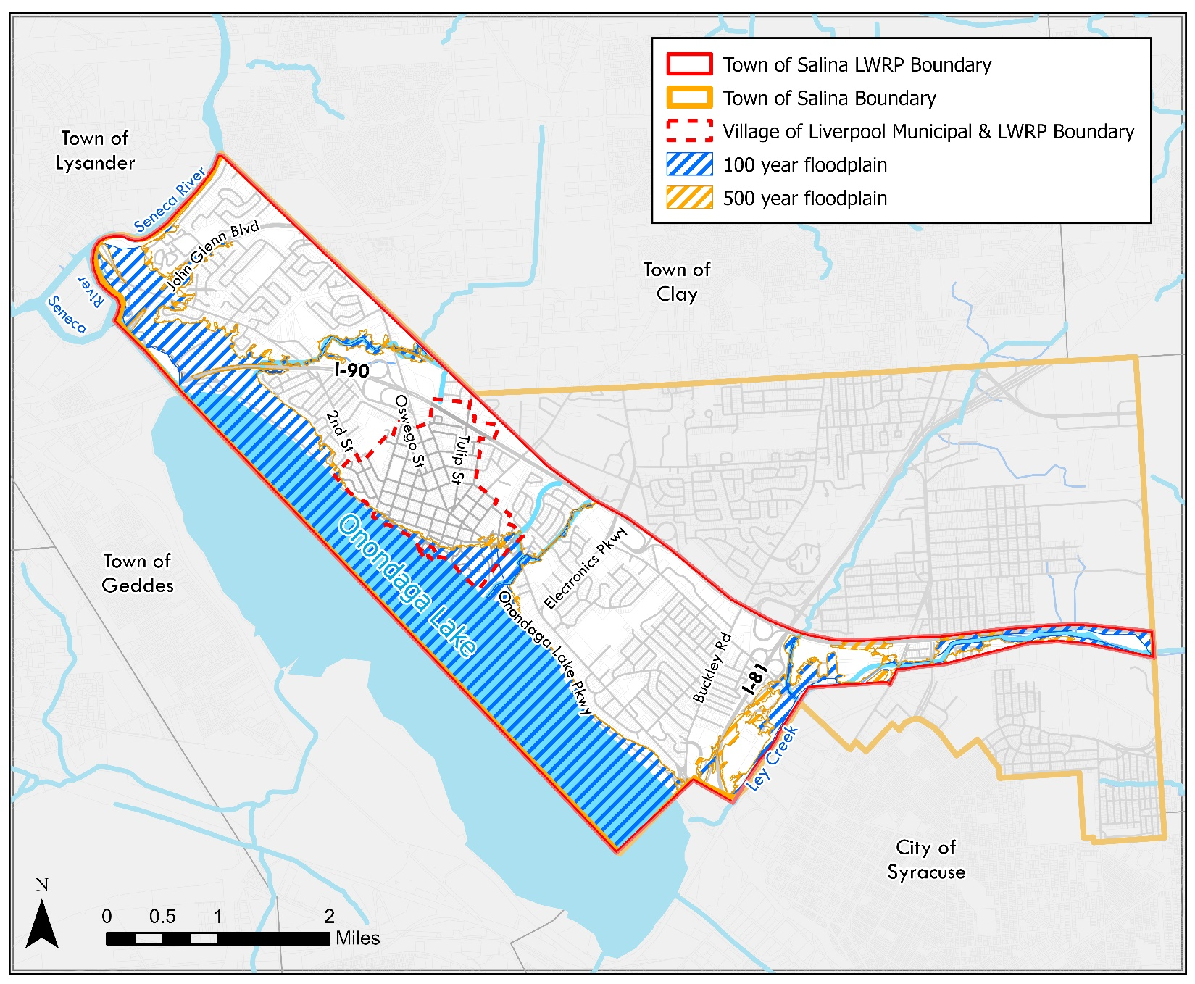
Figure 11 Floodplains in the WRA
The 500-year floodplain is located in the area just north of the Salina St and Pearl St intersection, as well as along I-81. While the floodplain generally does not go very far inland, the areas where it does coincide with the WRA’s recreational resources are clustered along the shoreline of Onondaga Lake (Onondaga Lake Park, Onondaga Lake Multi-Use Pathway, and Willow Bay Park).

Wetlands
Article 24, the NYS Freshwater Wetlands Act, was amended in 2022 with provisions going into effect in 2025 and 2028 that may bring some additional freshwater wetlands in the Town and Village under the jurisdiction of NYSDEC. In 2025, the jurisdictional nature of the existing state freshwater wetlands maps has been eliminated by removing “as shown on the freshwater wetlands maps” in the definition of Freshwater wetlands in § 24-0107.1. NYSDEC jurisdictional determinations and wetland classifications will be made remotely based on wetland acreage and characteristics meeting jurisdictional criteria. Small wetlands of "unusual importance" will be regulated if they meet one of 11 newly established criteria listed in the new legislation. These criteria are as follows, the wetland:
- is located within an area that has or is expected to experience significant flooding;
- is located within or adjacent to an urban area (as defined by the U.S. Census Bureau);
- contains a rare plant species;
- contains “habitat for an essential behavior” of an animal species that is endangered, threatened, of special concern, or of greatest conservation need;
- is classified by NYSDEC as a Class I wetland;
- was previously classified and mapped by NYSDEC as a wetland of “unusual local importance”;
- is a vernal pool “known to be productive for amphibian breeding”;
- is designated as a floodway by FEMA;
- was previously mapped by NYSDEC as a wetland before January 1, 2025;
- has “wetland functions or values that are of local or regional significance”; or
- is of significant importance to protecting state water quality.
As a result, it will be more important to contact NYSDEC to determine whether a wetland is 12.4 acres or larger or of unusual importance and therefore subject to NYSDEC regulation.
In 2028, the threshold for state-regulated wetlands will be reduced from 12.4 acres to 7.4 acres (also in § 24-0107.1), potentially bringing more wetlands under NYSDEC’s jurisdiction. Sponsors of proposed projects in Section 4 should be aware of the law in effect at the time they undertake development and determine its applicability before commencing work.
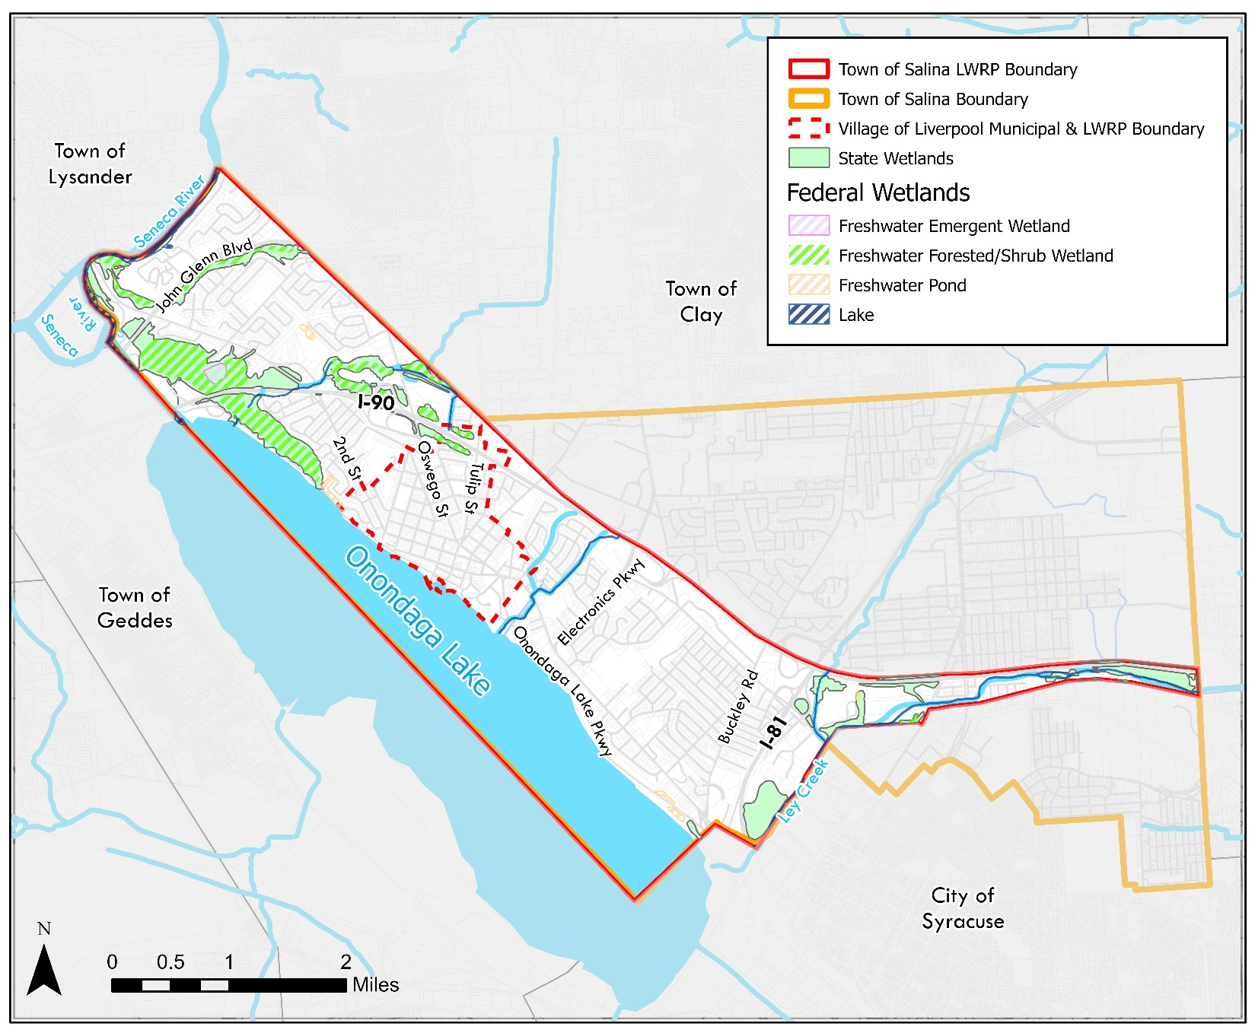
In addition to the State Regulated Wetlands, there are Wetlands within the WRA that are a part of the National Wetlands registry. This includes areas of freshwater forest/shrub wetlands in the northwestern areas along with a patch of freshwater emergent wetlands between I-90 and Long Branch Rd, scattered freshwater pond areas through the WRA.
Figure 12 Wetlands in the WRA

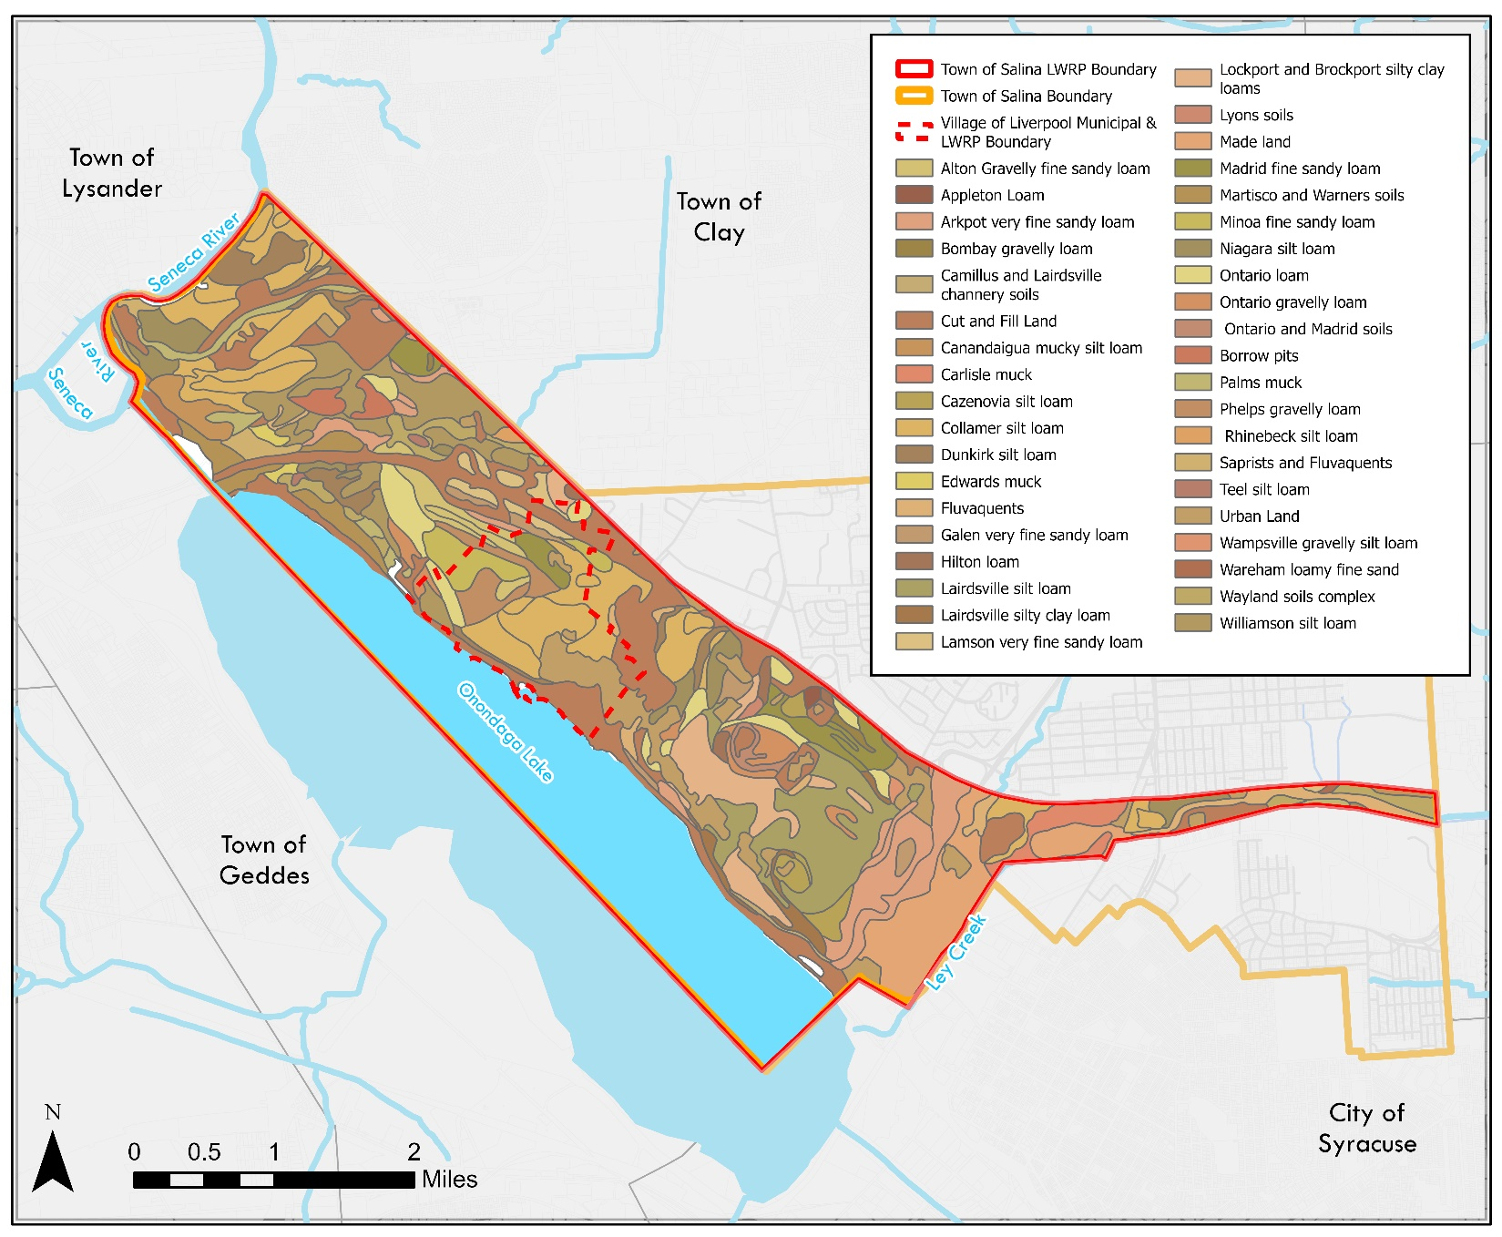
Soils
Figure 13 Soils in the WRA

There is a large variety of soils found within the WRAs: of the 53 different soil types found, 6 make up approximately 48 percent of the area. Table 5 represents the most prevalent soils within the WRAs, the name of the soil, its abbreviation, and how many acres it covers. Figure 9 displays where the soils are located in the WRAs.

Table 5 Soils found in the Waterfront Revitalization Area
Soil Name | Abbreviation | Coverage (acres)
Cut and Fill Land | CFL | 1,374
Collamer silt loam, 2-6 percent slope | ChB | 570
Urban Land | Ub | 444
Lairdsville silt loam, 2 to 6 percent slopes | LaB | 436
Made land | ML | 414
Collamer silt loam, 0-2 percent slope | ChA | 378

Rare Plants and Rare Animals
The WRAs is within the vicinity of the American Salt Marsh Bulrush, Annual Saltmarsh Aster, and Red Pigweed, listed as threatened, and the Straight-leaved Pondweed, which is listed as endangered.

Invasive Species
Invasive species found within the WRAs include: Common Reed Grass, Brown Marmorated Stink Bug, Tree-of-heaven, Jumping Worms, Asian Clam, Common Carp, Quagga Mussel, Yellow Iris, Purple Loosestrife, Round Goby, White Polar, Common Buckthorn, Water Chestnut.

Pollution
Onondaga Lake, once a thriving recreational destination, became one of the most polluted lakes in the United States due to decades of industrial and municipal waste disposal. Beginning in the late 19th century, industries discharged hazardous substances, including mercury, ammonia, and PCBs, directly into the lake. Additionally, sewage overflow and untreated stormwater from the Metropolitan Syracuse Wastewater Treatment Plant (Metro) exacerbated water quality issues, leading to algal blooms, oxygen depletion, and significant harm to aquatic ecosystems. By the mid-20th century, recreational activities such as swimming and fishing were banned, and the lake was designated a federal Superfund site in 1994. Furthermore, the Town of Salina experiences localized flooding during heavy rain events adding to potential impacts on Onondaga Lake and its tributaries.

Key Pollution Sources and Impacts
Over 100 years of industrial activities introduced mercury, chemical byproducts, and sediment contamination. These pollutants have persisted in lake sediments, contributing to long-term ecological and public health risks. Sewage and stormwater runoff carried ammonia, phosphorus, and other nutrients into the lake, creating conditions for frequent algal blooms and reduced water clarity. Combined sewer overflows (CSOs) also introduced bacteria and debris during heavy rainfall events.

Cleanup and Ongoing Efforts
Significant remediation efforts have transformed Onondaga Lake. Industrial remediation, led by Honeywell and overseen by the New York State Department of Environmental Conservation (NYSDEC) and the Environmental Protection Agency (EPA), included sediment dredging completed in 2014, capping polluted areas, and habitat restoration along the shoreline and tributaries. Metro has also upgraded its wastewater treatment systems, drastically reducing phosphorus and ammonia discharges. Current initiatives focus on preventing nonpoint source pollution and invasive species control.
The history and persistence of pollution in Onondaga Lake must be factored into planning for waterfront revitalization. While remediation has greatly improved water quality, sediment contamination remains a concern, limiting potential uses of certain areas. Additionally, future development within the Waterfront Revitalization Area (WRA) must prioritize stormwater management, habitat protection, and sustainable land use to prevent further degradation and support ecological recovery. Coordination among local, county, and state agencies will be essential to align development goals with ongoing restoration projects and ensure that recreational and economic opportunities can be realized without compromising environmental progress.

Environmentally Sensitive Features
There are five environmentally sensitive remediation sites in the WRA boundary that may hinder future development projects. Sites include the Martin Marietta Electronics Park, The Ley Creek Corridor (Old Ley Creek Channel Site and Lower Ley Creek), Old Salina Municipal Landfill, and Urban Villages. Information regarding these sites were gathered using the NY DEC Environmental Site Remediation Database.

Bloody Brook
This site is an approximately 5,000 foot long brook that’s stretches from the NYS Thruway to the Onondaga Lake Parkway. GE operated a plant upstream until Martin-Marietta purchased the plant from GE in the early 1990s, which then merged with Lockheed to become Lockheed-Martin Corp (LMC). Lockheed Martin entered into a Voluntary Cleanup Agreement with the DEC in 2002, and excavated more than 39,000 tons of sediment and soil from the brook channel, side bank and properties adjacent to the brook, completing remediation of the site in 2012.

Seneca River Wetlands and Floodplain
The floodplains and wetlands surrounding the Seneca River are ecologically significant features within the LWRP boundary that may affect development. On the western edge of the Town of Salina, a large undeveloped property sits between Route 370 and Grenadier Village, directly along the Seneca River. The privately owned site lies largely in the floodplain and contains wetlands. Due to ownership the environmental conditions of the site are not presently known.

Salina Town Landfill
The site is approximately 53 acres, and was a municipally operated landfill located off of NYS Route 11. It is an un-lined landfill established in a flood-prone wetland next to Ley Creek. From the 1950s to the 1970s, it received domestic, commercial and industrial wastes. Additionally, there is documented disposal of hazardous waste from the General Motors Fisher Guide Division. A Remedial Investigation/Feasibility Study (RI/FS) was completed for this site. This investigation identified VOCs and PCBs in the soil at the site which contributed to the known groundwater contamination as well as leachate outbreaks to Ley Creek, documenting that the existing cover was not adequate. The Remedial Action start for Landfill Closure and Waste Relocation/Consolidation was November 2010 and was completed in December 2013. Construction of the leachate/groundwater pre-treatment facility began in May 2014 and was completed in April 2015. Ley Creek, a major tributary of Onondaga Lake, formerly flowed along the eastern and southern edges of the landfill. However, in the 1970s, the Army Corps of Engineers rerouted the creek through the southeast corner of the landfill, thereby creating an isolated waste deposit (south section of landfill) and backwater area (Old Ley Creek channel). Sediments in much of Ley Creek are contaminated with PCBs.

Urban Villages
The site is 11.6 acres and is bounded to the north by medical offices, to the south by the convergence of several roadways (Buckley Road, Park Street, Old Liverpool Road, and Onondaga Lake Parkway). The site is developed with eleven former buildings (currently vacant and unused) that were associated with the operations of the Will & Baumer Candle Co. throughout its history at the property. The eleven buildings were historically used as offices, manufacturing spaces, a laboratory, press and pan rooms, multiple shed, a digester house, still house, a store room, a machine ship, a bleach house, a bleach yard, an oil house, and packaging and decorating areas. Multiple storage tanks including grease and oil as well as an acid tank and a fuel oil tank were identified on historic maps in the southeastern portions of the site. Railroad spurs run between the site buildings on the eastern portion of the site running north and south from at least 1911 until at least 1990. In addition, a refinery building was located adjacent south in at least 1911.

Old Ley Creek Channel Site
The site is 3 acres and consists of the former channel of Ley Creek, a small portion of land east of the channel and west of NYS Route 11. Ley Creek was rerouted in the early 1970s, turning this former channel into a tributary to the new channel of Ley Creek. Ley Creek, a Class B stream, is a tributary of Onondaga Lake. In accordance with NYCRR Part 895.3, the former channel of Ley Creek would be considered a Class B stream, and therefore considered a protected stream. Access to this site is unrestricted, and the property is next to a public thoroughfare. The site poses a significant threat to fish and wildlife. USEPA has agreed to redefine the Lower Ley Creek site (No. 734123)with the addition of the Old Ley Creek Channel site. Contaminant levels in sediment exceed the severe effect limits for aquatic plants and animals. The current Ley Creek channel sediments were sampled in 1998 as part of the Salina Landfill remedial investigation/feasibility study (RI/FS), and have been found to contain levels of PCBs at greater than 80 ppm, chromium at levels greater than 1,700 ppm and other heavy metals exceeding their respective SELs. Access to this site is unrestricted, and the property is next to a public thoroughfare. The site poses a significant threat to fish and wildlife. In 2010, DEC performed RI sampling and determined that PCBs are the major contaminant of concern in the surface soil at the site.

Lower Ley Creek
The site consists of the lower 2 miles of Ley Creek beginning at the crossing of Ley Creek by Route 11 (a.k.a. Brewerton Road) and ending downstream at the mouth of Ley Creek at Onondaga Lake. Site Features: The main site features include the creek and creek sediments. The creek itself is not used commercially. The site was listed on the National Priorities List (NPL) in July 2010 as a sub-site to the Onondaga Lake NPL Site. Prior to the early 1970s, poor channel conditions and large impermeable areas in the vicinity of the creek caused extensive flooding of Ley Creek. In an effort to alleviate flooding, Ley Creek was dredged in the 1970s, and the dredged material was placed along the banks of the creek. Prior to 1938, the area was generally used for agriculture. Contaminant levels in sediment exceed the severe effect limits for aquatic plants and animals. EPA sampling in 2010 and 2011 documented the presence of PCBs at hazardous waste levels in both the sediments and soils. In addition, sediment sampling showed levels of heavy metals exceeding the DEC Fish & Wildlife Severe Effect Levels (SEL). For example, chromium was found at a concentration of 6,290 ppm, well above the SEL of 110 ppm. Access to this site is unrestricted, and the property is next to a public thoroughfare. The site poses a significant threat to fish and wildlife. The June 2013 RI performed by EPA determined that PCBs are the major contaminant of concern in the sediment and soil at the site. An EPA ROD was issued for the site on September 30, 2014. The ROD, in part, called for sediment removal to PCB concentrations of 1 ppm PCB in the creek, and soil excavation to 1 ppm PCB in the top 2 feet and 10 ppm PCB below 2 feet.

Harbor Management area Planning
The NYS Executive Law, Article 42-Waterfront Revitalization of Coastal Areas and Inland Waterways was amended in 1992 to provide local governments with the clear authority to comprehensively manage activities in nearshore areas within their LWRP boundary by developing comprehensive harbor management plans (HMPs) and local laws to implement these plans. Pursuant to the 19 NYCRR Part 603, an LWRP often incorporates an HMP addressing existing or potential water-dependent use conflicts and associated local controls. An HMP must include an inventory of local and regional conditions and needs including, as applicable, the competing needs of commercial shipping and recreational boating, commercial and recreational fishing and aquaculture, waste management, mineral extraction, dredging, public access, recreation, habitat and other natural resource protection, water quality, open space needs, aesthetic values, common law riparian or littoral rights and the public interest in underwater lands.
The town of Salina and village of Liverpool do not have a substantial need for control over activities within nearshore areas along Onondaga Lake. As such, a harbor management plan is not needed at this time.

Existing Authorities and Jurisdictions within the WRA
In general, the authority for the regulation of structures and uses above the mean high-water line in New York State is granted to the local municipalities. This is enacted locally by zoning and subdivision ordinances.
State regulatory authority rests principally with the NYSDEC for activities such as disturbance of the bed or banks of a protected stream or other watercourse; construction, reconstruction or repair of dams and other impoundment structures, construction, reconstruction or expansion of docking and mooring facilities, excavation or placement of fill in navigable waters and their adjacent and contiguous wetlands, and water quality certification for placing fill or undertaking activities resulting in a discharge to waters of the united states, pursuant to:
- Article 24, Freshwater Wetlands: for permits regarding activities that are proposed within the mapped State-regulated wetland areas or within a 100-foot wide adjacent area. Permit issuance standards are contained in the NYSDEC regulations found at 6 NYCRR Part 66359.
- Water Quality Certification - Under Section 401 of the Clean Water Act, NYSDEC has responsibility for issuing or denying Water Quality Certification (WQC) for the U.S. Army Corps of Engineers (USACE) Section 404 Nationwide Permits.
In addition to direct permit authority, the NYSDEC also consults with the NYS Department of State (DOS), the NYS Office of Parks, Recreation and Historic Preservation (NYS OPRHP) and the NYS Office of General Services (OGS) as part of its review of permit applications. Under some permit procedures, specific consent must be obtained from one or more of these agencies for the NYSDEC to issue a permit or, in the case of NYSDOS, the NYSDEC must ensure that its permits or other actions comport with New York’s Coastal Management Program.
Salina and Liverpool are not located in the State Coastal Area, so DOS does not regulate projects or condition permits here. Local governments are also asked to provide comments on proposed project required permits and located within the coastal area of the State.
Coordination with the NYS OGS Bureau of Land Management is required for projects involving underwater lands. Underwater lands, as defined by the NYSOGS, include lands currently or formerly under water. Additionally, structures, including historical fill materials, docks, piers, or other structures, located in, on, or above state-owned lands under water are regulated under the Public Lands Law. The owner of the upland property is known as the upland property owner.
The OGS Bureau of Land Management has the authority to convey interest in real property for the use of state-owned lands underwater. This includes transfer of property through easements and leasing of property through licenses and collection of fees. Therefore, any landowners, usually the upland landowner, interested in utilizing state-owned lands underwater for any purpose needs to contact the OGS to determine what the requirements may be for the property in question.
NYS OGS electronically maintains current information about applications and permitting processes on the land management webpage. Information includes the following:
- Joint application forms (United States Army Corps of Engineers/New York State) for permits/determinations to undertake activities affecting streams, waterways, water bodies, wetlands, coastal areas, and sources of water supply
- Instructions for completing the Joint Application
- Petition for a License, Easement, or Permit for docks, wharves, commercial marinas, and permanent structures
- Petition for an Easement for Permanent Structures
- Petition for Grant (fee title)
- Petition for an Easement for Pipelines or Cables
Federal authority rests with the USACE under Section 10 of the Rivers and Harbors Act 64 of 1899 and under Section 404 of the Clean Water Act. Under Section 10, a permit is required for any structure or work (including any dredge or fill) that takes place in, under, or over navigable water, or any wetland adjacent to navigable waters. Under this regulation, a permit is required from the USACE to place any dock, mooring, boat ramp, permanent inlet, spud barge or any other structure within or over the water of the Seneca River and Onondaga Lake. Under Section 404 of the Clean Water Act, a permit is required for activities which involve a discharge of dredged or fill material into a water of the United States including wetlands.
Discharge activities which will drain or flood wetlands or significantly disturb the soils of a wetland also require a permit under this section. Some Federal permits also require concurrence or consent from New York State agencies. In particular, Federal permits in the coastal zone require a concurrence from the NYSDOS that the project is consistent with New York coastal management policies and Federal Section 404 permits require the issuance of a Water Quality Certification by the NYSDEC. Similar to the DEC permits, Massena is not located in the State Coastal Area, so DOS does not regulate projects or condition federal permits here.
Some areas within the WRA, while not owned by a particular agency or authority, are required to abide by specific regulations set forth by agencies and authorities with jurisdiction. Agencies and authorities may manage resources through regulatory requirements such as permitting and other forms of compliance. Consultation with these agencies and authorities may be required as necessary for obtaining approval for specific projects. Consultation should be carried out during planning and prior to implementation of a project.
Section VI of the LWRP provides a complete list of actions and programs of State and federal agencies and authorities that could impact or be impacted by the approval and implementation this LWRP. Federal agencies and authorities manage a wide range of resources related to, but not limited to the environment, safety, social justice, and water use. Section VI of the LWRP lists federal agencies and authorities that may have jurisdiction within the WRA.

Market Analysis
As part of their contribution to the LWRP, 4Ward Planning Inc. analyzed the market conditions within the Salina WRA area and identified opportunity areas that can be leveraged to support economic growth within the Town of Salina. The full market analysis can be viewed in Appendix X.

Real Estate
The construction of the Micron Facility in the neighboring Town of Clay is expected to generate 49,000 jobs in the Syracuse Metropolitan Area (Madison, Onondaga, and Oswego Counties). This large influx of people into the local workforce is expected to spur development in the region, and Salina is positioned to leverage its resources to capture a portion of the future spending in the area.
Housing will be the number one priority for workers relocating into the region. As of August 2024, nearly 3,500 multi-family units are being proposed in the 20-minute Primary Market Area surrounding the WRA, suggesting housing developers are looking to capitalize on the development of the Micron Technology plant and subsequent housing demand from new workers. It is not unreasonable that ten percent of these units could be captured within the WRA. Overall, there has been very little housing growth in Salina for the past 14 years (274 units between 2010-2024). Current market prices for apartments are unaffordable for middle to low-income earners; therefore, developing ‘middle housing’ (duplex, triplex, townhomes, courtyard apartments, etc.) in the WRA could help meet the demand for a greater variety of housing options. There are currently more than 670 housing units (apartments, single/two-family homes) in ongoing development within the LWRP area, which should help bring some housing online as the Micron Facility is expected to break ground late 2025.

Retail
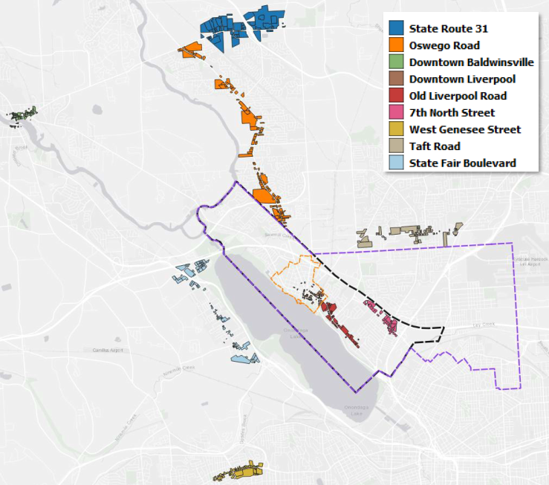
Compared to other downtowns and retail corridors in the area, Salina’s downtown has fewer food services and retail trade businesses, which is an area that could be expanded on to provide more diversity in local retail offerings.
Figure 14 Local Downtown and Retail Corridors
The investment into walkable, destination-style development would enhance the WRA’s commercial corridors. The 7th North Street corridor, would particularly benefit from ‘town center’ development, offering visitors staying in its lodging facilities and residents alike a place to walk, dine, and participate in events and entertainment.
There are opportunities to update Salina’s zoning to encourage mixed-use development, which could expedite the development of convenience retail goods and services (e.g., pharmacies, quick-service restaurants, and personal services) targeted to residents and workers. A mixed-use friendly zoning code could also support the creation of small-scale office spaces that are attractive for freelancers, startups, professionals, and consultants who need client-facing office spaces in accessible locations.

Summary of Opportunities and Constraints
The Waterfront Revitalization Area (WRA) in the Town of Salina and Village of Liverpool offers opportunities for development, recreation, and environmental stewardship. The Onondaga Lake and River areas provide existing public access points, such as the Onondaga Lake Park, Restoration Way Riverwalk, and public docks, which can be expanded to enhance recreational use and attract visitors. These assets also present opportunities to connect the waterfront with downtown business districts, leveraging the WRA’s proximity to major transportation routes like I-90 and I-81. This connectivity supports not only tourism and recreation but also broader economic development by integrating waterfront activities into the local economy.
The Village of Liverpool contains various opportunity zones including its central business district and a site located between the community’s primary commercial and social corridor, along First Street and Onondaga Lake Park. This site known as the Basin Block which contains vacant restaurants and unused lots and detracts from the vitality of the surrounding area. The Village of Liverpool’s central business district, located on First Street, offers well-designed streets and amenities but currently lacks elements of ADA accessibility, wayfinding signage and waterfront specific signage. Additionally, overhead utilities detract from the visual appeal of the streetscape and add the uncertainty of power outages and other hazards to the center of the village.
The ongoing remediation of Onondaga Lake has improved water quality and ecological health, creating a foundation for sustainable development. The area's history as an industrial hub, coupled with its cultural and natural heritage, offers potential for educational, recreational and interpretive events and initiatives to engage residents and visitors. The park improvements also open up further possibilities for seasonal programming that celebrates the area’s cultural identity, attracts visitors, and enhances the recreational experience of the waterfront. Furthermore, the WRA’s inventory of vacant and underutilized parcels provides a unique opportunity to pursue redevelopment projects that align with the LWRP’s goals while maintaining a commitment to environmental stewardship.
However, several constraints must be addressed to realize these opportunities. Persistent sediment contamination in Onondaga Lake and specific sites like Lower Ley Creek presents challenges for certain waterfront uses and requires careful planning to mitigate environmental risks. Physical barriers such as the Onondaga Lake Parkway and rail lines restrict access to portions of the waterfront, limiting connectivity between key areas. Aging infrastructure, including older housing stock and underdeveloped public facilities, requires modernization to meet current safety and accessibility standards.
The jurisdictional complexity of the WRA adds another layer of difficulty, as overlapping authorities and permitting requirements among entities like the NYS Department of Environmental Conservation (DEC), Department of State (DOS), and federal agencies can delay project implementation. Additionally, demographic trends, including declining populations in young family age groups, challenge the area’s ability to sustain economic and social vitality.
Balancing these opportunities and constraints will be essential in developing an actionable vision for the WRA. By addressing the challenges while capitalizing on the WRA’s unique assets, the Town and Village can create a sustainable waterfront that serves the economic and recreational needs of the community and attract visitors from across the region.

https://www.ocwa.org/about/sources-of-water/
http://www.ongov.net/wep/WWTP-MetroSyracuse.html
Source: NYS Senate NYS Open Legislation | NYSenate.gov
https://imapinvasives.natureserve.org/
https://dec.ny.gov/nature/waterbodies/lakes-rivers/onondaga-lake
https://dec.ny.gov/sites/default/files/2024-01/olreturntoglory.pdf
https://dec.ny.gov/environmental-protection/water/water-quality/clean-water-plans
https://extapps.dec.ny.gov/data/der/factsheet/olprogress1017.pdf
https://extapps.dec.ny.gov/data/der/factsheet/olprogress1017.pdf
https://extapps.dec.ny.gov/docs/legal_protection_pdf/USFWSFact2018.pdf
https://extapps.dec.ny.gov/cfmx/extapps/derexternal/?CFID=26538760&CFTOKEN=39596457&jsessionid=4F7B9B41281BFD09AF763A5A9A7F6966.p20
https://extapps.dec.ny.gov/cfmx/extapps/derexternal/haz/details.cfm?ProgNo=734074
https://extapps.dec.ny.gov/cfmx/extapps/derexternal/haz/details.cfm?ProgNo=734123

