SECTION 4: Proposed Land and Water Uses

Vision
The Salina–Liverpool waterfront will be a vibrant and sustainable destination that celebrates Onondaga Lake’s natural beauty, recreational opportunities, and cultural heritage. The waterfront will complement the character of the Village and Town, offering clear and welcoming access points that seamlessly connect the shoreline with inland destinations. Enhanced wayfinding, improved streetscapes, and well-managed parking will guide visitors between the waterfront and community, while pedestrian, bicycle, and transit amenities will provide safe and convenient travel options. Together, this interconnected system of parks, trails, cultural landmarks, and commercial areas will foster economic vitality, environmental stewardship, and a strong sense of place for residents and visitors alike.

Goal Categories and Preliminary Projects:

Economic Development
Salina and Liverpool will foster a vibrant waterfront economy that strengthens community character while creating new opportunities for commerce, recreation, and cultural activity. Redevelopment of key sites, expansion of mixed-use spaces, and activation of underutilized properties will support local businesses and attract visitors year-round. Seasonal programming, signage, and public amenities will further integrate the waterfront with the Village and Town, making it a hub of economic vitality and a welcoming gateway to the community.
- Seneca River Marina Acquisition & Development
Adjacent to Grenadier Village, a major rental community on the Seneca River, is a privately owned marina that provides docking facilities, a boat launch, and direct river access. The Town of Salina is currently exploring acquisition of this property, and doing so presents an important opportunity not only to secure long-term public access but also to undertake much-needed improvements to a deteriorated waterfront asset.
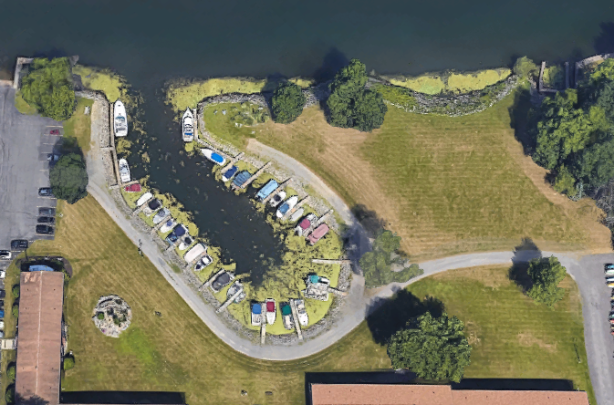
The marina’s existing conditions underscore the need for both acquisition and redevelopment. The docks are aging and in poor condition, dredging is needed to improve navigability and safety, and the boat launch and shoreline access require upgrades. Paved access and circulation improvements would enhance usability, improve ADA accessibility, and support more efficient site operations. Under public ownership, the Town would be able to address these deficiencies comprehensively, modernize infrastructure, and create a well-maintained, fully functional marina that serves a wide range of residents and visitors.
Figure 1 Aerial image of the existing Seneca River Marina at Grenadier Village Apartments
Transforming the marina into a publicly owned and improved facility would deliver significant recreational and economic benefits. Enhanced amenities such as upgraded docking, improved launching facilities, dredged navigation channels, and better site access would strengthen the riverfront’s appeal as a regional boating and recreation destination. Public stewardship would also allow the marina to be integrated with broader waterfront revitalization efforts, including connections to nearby neighborhoods, future trail systems, and river-based programming. The acquisition and redevelopment of the Seneca River Marina would secure a critical waterfront resource, elevate the quality of recreational opportunities, and advance the long-term goals of the LWRP.

- Policies: 1, 2, 4, 5, 9, 18, 19, 20, 21, 25, 34, 41, 42, 43, 44
- Lead Agency: Town of Salina
- Cooperating: Private property owner;
- Funding: DOS, ESD, NYSFOLA, OPRHP, Association of Marina Industries
- Priority: Medium

- Mixed-Use and Redevelopment Initiatives
The Basin Block is a key site within the Village of Liverpool, strategically located between the community’s primary commercial and social corridor along 1st Street and Onondaga Lake Park. While one end of the block supports long-standing businesses that contribute to the Village’s identity, the opposite end, referred to as the Gormel property and Basin block, contains vacant restaurants and unused lots that detract from the vitality of the area. This project proposes redevelopment and reinvestment in the Basin Block, with a strong emphasis on repurposing existing structures and pursuing mixed-use development that integrates residential, commercial, and community uses. At a minimum, vacant buildings should be returned to active use through multi-purpose redevelopment rather than single-use apartment complexes.
Redeveloping the Gormel properties would restore vitality to a highly visible gateway into both the Village and Onondaga Lake Park. Mixed-use development would support local businesses, create housing options, and enhance the pedestrian-oriented character of the Village core. Coordinated planning across the Basin Block would ensure that redevelopment strengthens both the downtown corridor and its connection to the waterfront, reinforcing Liverpool’s identity as a vibrant, walkable, and economically resilient community.
Future redevelopment planning should include evaluation of water, sewer, stormwater, access, and parking needs to ensure that new mixed-use development can be supported without negatively impacting surrounding businesses, residents, or public infrastructure.
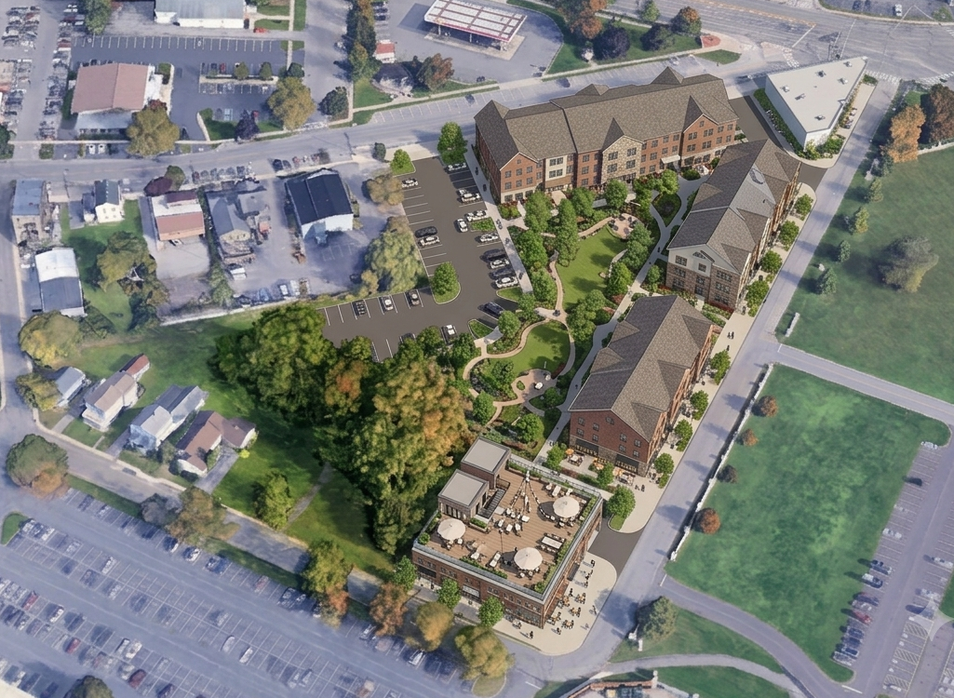
- Policies: 1, 5, 25, 41, 42, 43
Figure 2 Conceptual rendering illustrating a long-term vision for mixed-use redevelopment of the Basin Block, including new mixed-use buildings, enhanced internal circulation, rooftop gathering space, and a central courtyard. (Source: Google Earth and AI Conceptual Visualization: Gemini.)
- Lead Agency: Village of Liverpool
- Cooperating: Town of Salina; developers / owners
- Funding: DOS, Restore NY, Regional Council Capital Fund Program, CDBG
- Priority: Medium

- Wayfinding and Informational Waterfront Signage
This project proposes the installation of a coordinated system of wayfinding and informational signage to strengthen the physical and visual connection between Onondaga Lake Park and the Village of Liverpool. Working in partnership with Onondaga County, the Village proposes installing signage along key waterfront access points, including Tulip Street, Vine Street, Sycamore Street, Birch Street, Lake Drive, and South Willow Street. These signs will direct trail users and park visitors into the Village center, highlight available businesses and amenities, and improve overall navigation for residents and visitors.
All new signs will follow the County’s existing branding and design standards to maintain a consistent visual identity throughout the Onondaga Lake Park system. In addition to directional signage, this project includes enhanced interpretive signage at Hiawatha Point to better communicate the area’s historical and cultural significance. This would require close coordination with the County and the Onondaga Historical Association.
The Village intends to take responsibility for the ongoing maintenance and periodic updating of these signs to ensure they remain accurate, well-kept, and reflective of local offerings. Strengthening wayfinding throughout the waterfront area will improve visitor experience, support local businesses by guiding more foot traffic into the Village, and reinforce Liverpool’s identity as a welcoming, accessible, and connected community.
Public feedback emphasized the need for signage that better recognizes the Haudenosaunee presence, history, language, and continued cultural significance within the waterfront area. Where appropriate, wayfinding and interpretive signage should be developed in coordination with the Onondaga Historical Association, Onondaga County, and Haudenosaunee representatives, and may include dual-language elements.
- Policies: 1, 5, 18, 19, 20, 22, 25,
- Lead Agency: Village of Liverpool
- Cooperating: Onondaga County; Town of Salina, Onondaga Nation / Haudenosaunee representatives
- Funding: DOS, ESD Market NY Tourism Grant Program, OPRHP
- Priority: High

- Seasonal and Event Programming
The Village of Liverpool and Town of Salina support Onondaga County’s existing programming at Onondaga Lake Park and along the Parkway Trail and are eager to see these efforts expanded. This project proposes the development of additional year-round programming, including both seasonal events and new recreational offerings that celebrate the area’s cultural identity, draw visitors, and enhance the overall waterfront experience.
Potential programming includes lantern festivals, food and beverage festivals, seasonal markets, and themed activities such as a jack-o’-lantern walk. Establishing a winter ice-skating rink along the waterfront would provide a unique cold-weather recreational attraction that complements existing park amenities. This could take the form of a temporary seasonal installation or a more permanent structure. Such a feature would be implemented by Onondaga County, with support from the Town and Village.
The Village and Town would collaborate with the County and other partners to identify opportunities, coordinate logistics, and promote events that align with community goals while attracting new audiences to the waterfront. Expanding year-round programming would activate the waterfront throughout all seasons, support local businesses, strengthen community identity, and reinforce Onondaga Lake Park as a regional destination for recreation, culture, and family-friendly activities.
Public feedback expressed strong interest in a winter ice-skating rink and a flexible outdoor space that could support seasonal recreation and events throughout the year. Potential locations, including the former Griffin/Griffith Field area, should be evaluated for feasibility based on ownership, site access, parking, utilities, restroom availability, lighting, safety, and compatibility with surrounding uses.
- Policies: 1, 2, 4, 18, 19, 21, 25,
- Lead Agency: Onondaga County
- Cooperating: Village of Liverpool; Town of Salina
- Funding: DOS, NYSCA
- Priority: High

Recreation
Salina and Liverpool will promote a connected and inclusive system of parks, trails, and waterfront amenities that provides year-round opportunities for play, relaxation, and community gathering. The Town and Village will invest in safe, high-quality facilities that serve all ages and abilities, link neighborhoods to the waterfront, and strengthen Onondaga Lake as a regional destination for recreation and leisure.
- Sunflower Neighborhood – Bloody Brook Trail Link
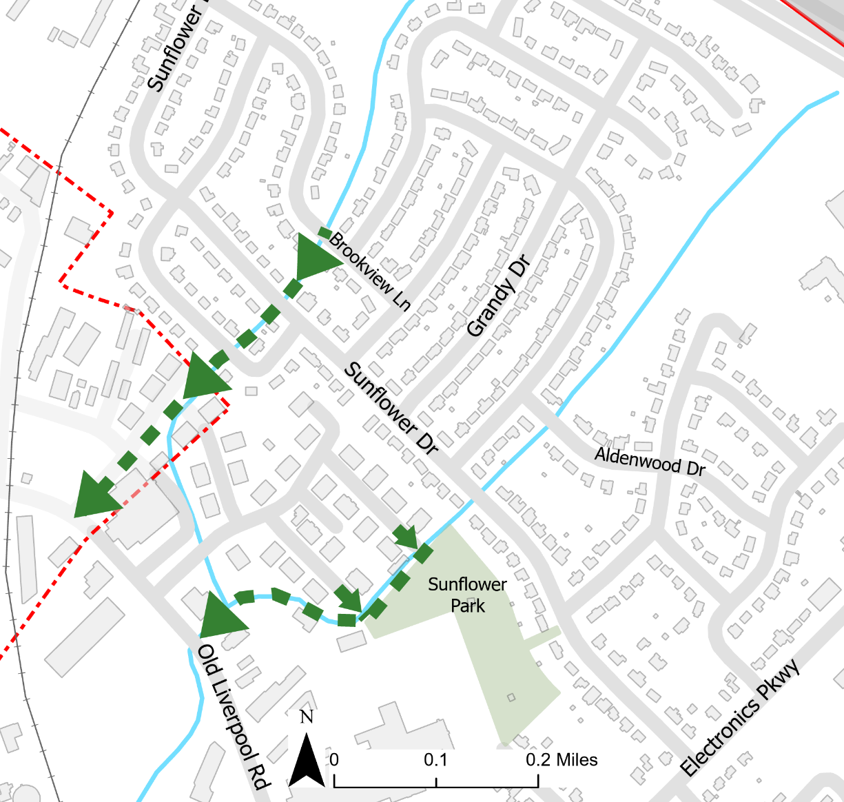
The Sunflower Neighborhood currently has limited access, with only two automotive entry points along Electronics Parkway and a lack of pedestrian access. This lack of pedestrian connectivity restricts mobility options for residents and limits safe, non-motorized access to surrounding areas and the waterfront. This project proposes creating a multi-use trail along the existing easements of Bloody Brook, which runs through the neighborhood and converges at Old Liverpool Road before flowing to Onondaga Lake. By leveraging these easements, the project would establish a direct pedestrian and bicycle connection from the Sunflower Neighborhood to Old Liverpool Road and ultimately to the future Loop-the-Lake Trail. The trail would provide safe, convenient, and scenic access to Onondaga Lake while also enhancing recreational opportunities, supporting active transportation, and improving neighborhood connectivity.
- Policies: 1, 4, 9, 18, 19, 20, 25, 41
- Lead Agency: Town of Salina
- Cooperating: Village of Liverpool; private property owners;
- Funding: DOS, RTP administered by OPRHP, PTPP administered by OPRHP, SS4A
- Priority: Medium

Figure 3 A trail map illustrating a potential connection between the Sunflower Neighborhood and Old Liverpool Road through future trail easements along Bloody Brook.
- Ley Creek Greenway Connection
The Ley Creek corridor has historically been overlooked due to its industrial surroundings and proximity to the landfill, resulting in limited public use and poor connectivity. Despite these challenges, the area offers significant potential as a greenway that can serve as a recreational and transportation link between neighborhoods and regional trail systems.
This project proposes developing a multi-use trail along Ley Creek that would connect to the existing and planned segments of the Bear Creek Trail and ultimately tie into the future Loop-the-Lake Trail. In addition, the greenway could create future opportunities for expanded connections into the Lyncourt neighborhood, into the City of Syracuse, and further along the Ley Creek corridor.
By reclaiming and reinvesting in this underutilized area, the project would transform Ley Creek into a community asset, improve recreational access, and provide a vital non-motorized transportation link that connects neighborhoods to Ley Creek, Onondaga Lake, and the broader regional trail network.
- Policies: 1, 4, 5, 9, 18, 19, 20, 25, 41
- Lead Agency: Town of Salina
- Cooperating: National Grid (owns some land); Onondaga County (owns some land)
- Funding: DOS, RTP administered by OPRHP, PTPP administered by OPRHP, SS4A
- Priority: Medium
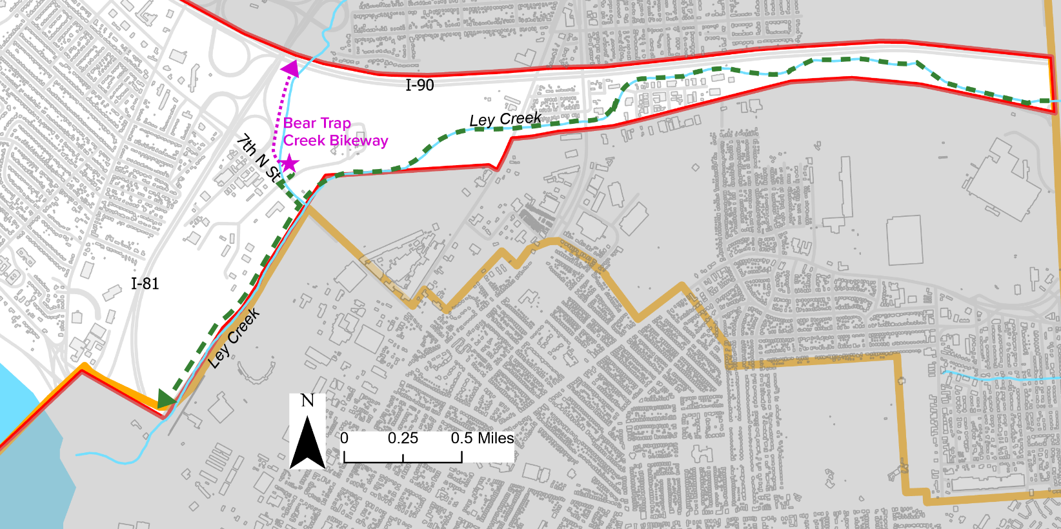
Figure 4 A trail map illustrating the proposed Ley Creek Greenway Connection and its potential connections to the Bear Trap Creek Bikeway and the future Loop-the-Lake Trail.
- Loop-the-Lake Trail Completion
Although Onondaga Lake already hosts a network of trails, such as the East Shore Recreation Trail, West Shore Trail, and Shoreline Walking Trail, there remains a gap in the trail system along the Onondaga Lake Parkway in the Town of Salina that prevents a continuous loop around the lake. Completing this missing link is critical to fulfilling the “Loop-the-Lake” vision and ensuring seamless, regional trail connectivity for pedestrians and cyclists.
This project will plan and construct the final trail section alongside the Onondaga Lake Parkway to close the loop. The route would be designed for multi-use (walking, biking) and integrate with the existing trail network in Onondaga Lake Park. Geographic alignment will be determined through field review and coordination with the County Parks Department, NYS DOT, and other stakeholders. The plan will also consider trail width, surface materials, safety crossings, signage, and compatibility with adjacent park amenities.
Completing the Loop-the-Lake Trail will establish a continuous 11–12+ mile multi-use trail around Onondaga Lake, linking neighborhoods, parks, and regional destinations. This connection will encourage active transportation and recreation, drawing both residents and visitors while strengthening ties between the waterfront, the Village of Liverpool, the Town of Salina, and the broader regional trail network. The project will also enhance economic opportunities by increasing foot and bicycle traffic near commercial and recreational areas, while supporting community health and environmental goals through expanded access to greenways and sustainable mobility options.
- Policies: 1, 4, 5, 9, 18, 19, 20, 25, 41
- Lead Agency: Onondaga County
- Cooperating: Town of Salina; Village of Liverpool; CSX (?)
- Funding: DOS, NYSDOT, RTP administered by OPRHP, PTPP administered by OPRHP, SS4A
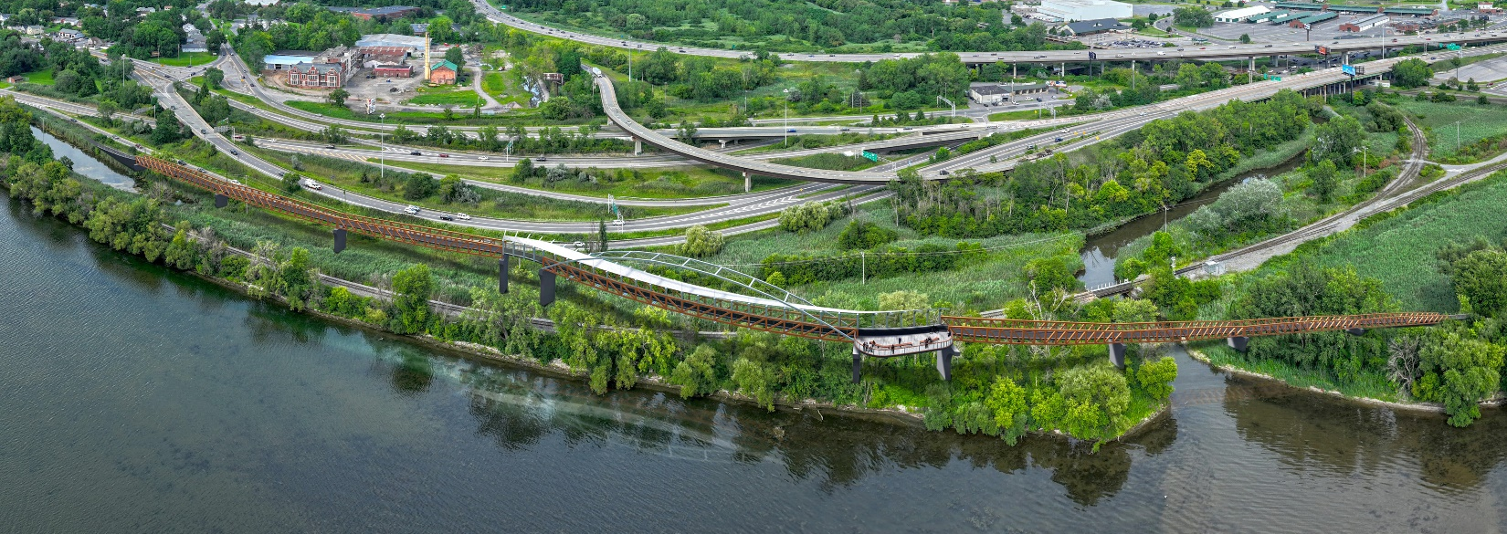
- Priority: High
Figure 5 Conceptual plan illustrating a potential completion of the Loop-the-Lake Trail between Murphy's Island and the Town of Salina via a new pedestrian bridge and elevated walkway crossing Ley Creek and the railroad. (Source: Barton & Loguidice)

- Washington Park Enhancements
Washington Park is a valued community green space in the Village of Liverpool, offering walking paths, playgrounds, picnic areas, gardens, and open space that support family outings, passive recreation, and community events. While the park already provides a welcoming environment, enhancements are needed to ensure it continues to meet the recreational and social needs of the community.
Potential improvements include upgrades to play equipment, refreshed landscaping, improved seating and picnic facilities, and expanded amenities to support gatherings and events. In addition, the Village has expressed interest in updating and strengthening the park’s dedication to veterans, ensuring that this important recognition remains prominent, well-maintained, and reflective of the community’s appreciation.
Together, these enhancements will reinforce Washington Park’s role as a central neighborhood park, enrich the visitor experience, and strengthen its connection to the Village’s broader network of waterfront and community recreation amenities.
- Policies: 1, 5, 19, 20, 25
- Lead Agency: Village of Liverpool
- Cooperating: Town of Salina;
- Funding: DOS, MRP administered by OPRHP, EPF administered by OPRHP, Syracuse Parks Conservancy
- Priority: Low

- Johnson Park Enhancements
Johnson Park is a central gathering space in the Village of Liverpool, well-known for its gazebo, fountain, and stage that hosts live music and community programming such as the Liverpool Is The Place summer concert series. The park also offers picnic areas and shaded green space that attract daily visitors. To maintain its role as a signature civic and cultural destination, enhancements are proposed to strengthen amenities, modernize aging features, and better accommodate both large events and everyday use.
A key focus of this project is the performance stage, which requires structural repairs and upgrades. Needed improvements include brick restoration, roof enhancements to provide more effective shading for performers, and structural work such as waterproofing and foundation reinforcement to extend the life and safety of the stage. Additional improvements include upgrades to seating areas, restoration of the gazebo and fountain, expanded picnic facilities, and landscape and lighting enhancements throughout the park.
- Policies: 1, 5, 19, 20, 25
- Lead Agency: Village of Liverpool
- Cooperating: Town of Salina;
- Funding: DOS, MRP administered by OPRHP, EPF administered by OPRHP, Syracuse Parks Conservancy
- Priority: High

- Lamb Park Enhancements
Memorial Park, historically known as Lamb Park, is a small but meaningful green space in the Village of Liverpool. Located on Oswego Street across from Vine Street, the park carries deep cultural and historic significance. Named after James Lamb, a state official in the salt industry, the park features a cannon dedicated in 1957 by the American Legion Post 188 to honor veterans of all U.S. wars. In 1977, as part of the U.S. Bicentennial, a time capsule was buried beneath a millstone to preserve local history for future generations. While the park provides a quiet reflective space, it is in need of enhancements to preserve its historic assets and improve its role as a community landmark. In particular, the cannon requires cleaning and possible refurbishment to ensure it continues to serve as a respectful tribute to veterans. Additional improvements may include landscaping, benches, interpretive signage, and lighting upgrades to strengthen the park’s visibility and honor its heritage as both a memorial and a place of community pride.
- Policies: 1, 5, 19, 20, 23, 25
- Lead Agency: Village of Liverpool
- Cooperating: Town of Salina; American Legion Post 188
- Funding: DOS, MRP administered by OPRHP, EPF administered by OPRHP, SHPO, Technical Assistance Grant administered by the Preservation League of NYS, Syracuse Parks Conservancy
- Priority: Low

- Carriage Park Recreation Enhancements
A small triangular greenspace sits at the intersection of Tulip Street, Tamarack Street, and Park Street. Though unnamed, it is informally known as Carriage Park in reference to a former play structure (a carriage and horses) that once occupied the site. The space is owned by the Village as part of the public right-of-way and totals roughly 23,000 square feet. Mature trees line the perimeter and create a shaded, quiet environment that offers a pleasant break within the surrounding residential neighborhood.
This project proposes enhancing the greenspace for passive recreation while preserving its informal, neighborhood-oriented character. Potential improvements include new seating and small gathering areas, low-maintenance landscaping, pathways or stepping-stone routes, and modest placemaking elements such as interpretive signage or public art. Tree care and additional shade plantings could further strengthen the park’s comfort and ecological value. Since the site is modest in scale and set within a right-of-way, improvements would focus on simple, low-impact features that create a welcoming spot for rest, reading, conversation, and everyday community use.
- Policies: 1, 5, 19, 20, 25, 43
- Lead Agency: Village of Liverpool
- Cooperating: Town of Salina
- Funding: DOS, MRP administered by OPRHP, EPF administered by OPRHP, Syracuse Parks Conservancy, SHPO, NYSCA, Urban and Community Forestry Grant DEC
- Priority: Low
- Seneca River Park Acquisition and Feasibility Study
On the western edge of the Town of Salina, a large undeveloped property sits between Route 370 and Grenadier Village, directly along the Seneca River. The privately owned site, much of which lies within a floodplain and contains wetlands, has been identified by the landowner as available for potential sale to the Town. This project proposes acquiring the property to explore the creation of a new waterfront park that would expand public access and strengthen recreational connectivity in this part of the community.
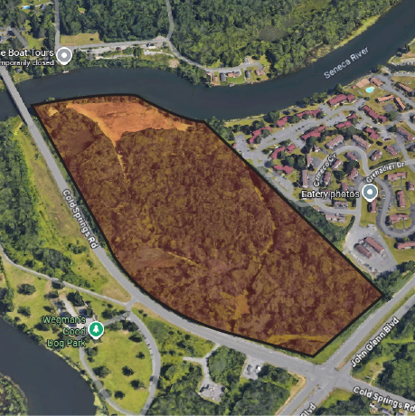
Following acquisition, the Town would undertake a feasibility study to evaluate environmental constraints, floodplain conditions, wetland boundaries, site access, and the range of recreational uses compatible with the property. The study would determine whether the site can support amenities such as walking and biking paths, riverfront overlooks, natural areas, or other low-impact recreational features that respect ecological conditions. It would also examine opportunities to establish a pedestrian and bicycle connection from Grenadier Village across Route 370 to the Onondaga Lake Parkway and, ultimately, the Loop-the-Lake Trail.
Creating a park at this location would provide a significant new recreational asset for residents of Grenadier Village and the surrounding neighborhoods, while enhancing the Town’s overall waterfront access. By pairing acquisition with a thorough feasibility and design analysis, this project positions the Town to thoughtfully transform underutilized riverfront land into a meaningful public resource that balances recreation, connectivity, and environmental stewardship.
- Policies: 1, 2, 17, 18, 19, 22, 25, 41, 42, 44
- Lead Agency: Town of Salina
- Cooperating: Private property owners, DEC, the Wetland Trust
Figure 6 Aerial image of a potential future waterfront acquisition area located along the Seneca River between Cold Springs Road and the Grenadier Village Apartments. (Source: Google Earth.)
- Funding: DOS, DEC, EPF, OPRHP, EPA Wetland Grants, North American Wetlands Conservation Act (NAWCA) Grants
- Priority: Medium

- Willow Bay Beach Development
Although the Onondaga County-owned waterfront parcels at Willow Bay provide public access to Onondaga Lake, they lack a formal, safe, and attractive swimming venue. The absence of a beach limits recreation options, constrains lakefront activation, and means the waterfront is underutilized for swimming and shoreline enjoyment.
The Willow Bay Beach project seeks to design and construct a new public swimming area at Willow Bay. Working in partnership with Onondaga County, the Town of Salina, and the Village of Liverpool, the project will develop beach infrastructure, such as shoreline grading, sand placement, water access points, and shoreline stabilization, along with support facilities like restrooms, changing rooms, lifeguard stations, seating, shade structures, and pedestrian access. Detailed planning would also consider water quality, stormwater management, public safety, and appropriate permit compliance. The design will aim to integrate with adjacent park features and existing pathways to connect the beach to surrounding trail networks, parking, and recreational nodes.
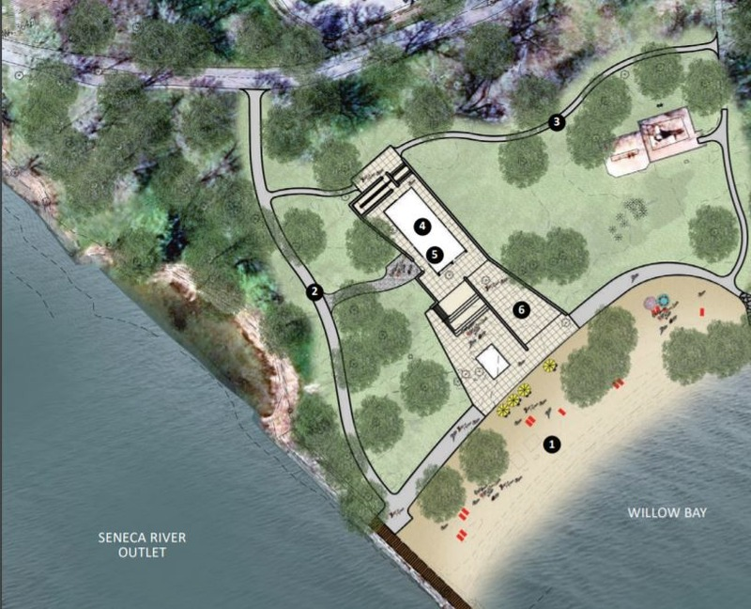
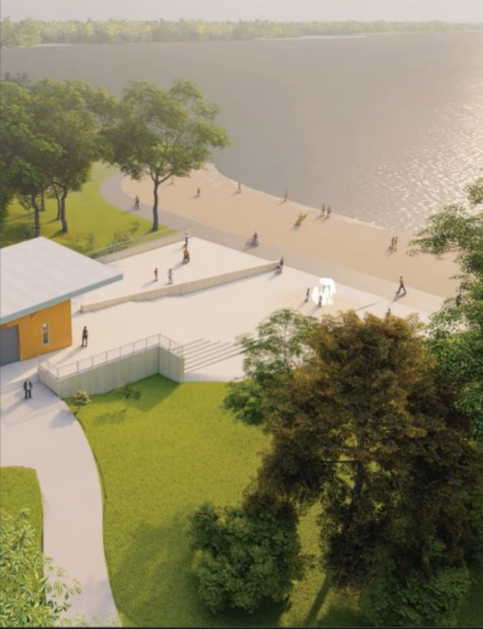
A well-designed beach at Willow Bay would significantly expand recreational opportunities, making Onondaga Lake more accessible for swimming and shoreline use. It would attract more visitors to the waterfront, creating positive economic spillovers for nearby businesses and civic amenities. The beach could serve as a focal point for waterfront activation, encouraging longer visits, greater public engagement, and increased use of adjacent trails and facilities. From a health and environmental perspective, safe and managed swimming conditions would help ensure that public use is balanced with water quality protection and ecological stability. In collaboration with the County, this project could help fulfill broader regional goals for a revitalized, vibrant, and community-centered lakefront experience.
Figure 7 reliminary concept plan and rendering illustrating a potential public beach and waterfront improvements at Willow Bay. (Source: Barton & Loguidice)
- Policies: 1, 2, 4, 5, 12, 17, 18, 19, 20, 21, 22, 25, 41, 42, 43
- Lead Agency: Onondaga County
- Cooperating: Town of Salina; Village of Liverpool
- Funding: DOS, EPF and MPR administered by OPRHP, Open Space Institute, NYSG, NY SWIMS
- Priority: Medium

Public Access and Infrastructure
Salina and Liverpool will strengthen connections between the waterfront, neighborhoods, and community destinations by investing in a safe, multimodal, and well-coordinated transportation network. This goal calls for implementing complete streets, extending sidewalks and trails, and improving intersections to make walking, biking, and transit safer and more inviting. Infrastructure upgrades, including wayfinding and utility improvements, will create seamless access that links the waterfront to the Village center, Town destinations, and the broader region.
- Village Waterfront Access Improvements
The Village of Liverpool’s downtown and waterfront are two of its strongest assets, but the physical and visual connections between them are limited. While Sycamore Street, Vine Street, and Tulip Street serve as the primary corridors linking downtown Liverpool to Onondaga Lake, these streets lack the pedestrian, bicycle, and streetscape amenities needed to function as inviting gateways. Without these enhancements, opportunities to draw waterfront users into the downtown and vice versa are missed.
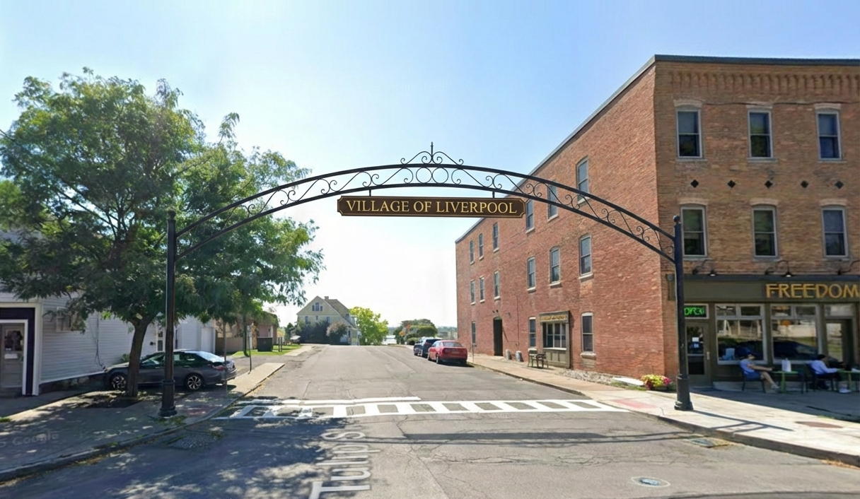
The Village Waterfront Access Improvements project would strengthen pedestrian and bicycle connections between the Village’s downtown and its waterfront by transforming Sycamore, Vine, and Tulip Streets into complete, attractive, and user-friendly corridors. Improvements may include continuous sidewalks, enhanced crosswalks, bicycle accommodations, street trees, lighting, benches, landscaping, and wayfinding signage. Tulip Street would receive special treatment with the installation of decorative arches at both the waterfront and downtown ends, symbolically and visually uniting these two key destinations. Streetscape enhancements across all three corridors would reinforce their roles as welcoming gateways.
Figure 8 Conceptual rendering illustrating a gateway arch in the Village of Liverpool. This rendering is for visualization purposes only and represents a long-term vision. (Source: Google Street View and AI Conceptual Visualization: Gemini)
The project would create safe, attractive, and intuitive routes between downtown Liverpool and the Onondaga Lake waterfront, encouraging residents and visitors to move seamlessly between the two areas. Enhanced streetscapes would improve walkability, promote cycling, and foster economic activity downtown by drawing waterfront users into local shops, restaurants, and cultural attractions. At the same time, the improved gateways would invite more visitors from the downtown core to experience the waterfront, strengthening the Village’s identity as a cohesive, connected, and vibrant community. Public feedback strongly supported improving these gateways to make the Village feel more connected to the waterfront for both locals and visitors.
- Policies: 1, 2, 4, 5, 9, 18, 19, 20, 22, 25, 41
- Lead Agency: Village of Liverpool
- Cooperating: Town of Salina; Onondaga County
- Funding: DOS, NYSDOT, SS4A, Transportation Alternatives Program, NY Main Street, PeopleForBikes Industry Community, various grants administered by FHWA
- Priority: High
- Birch Street Neighborhood Waterfront Access
Birch Street provides an important connection between the Village neighborhood and the Onondaga Lake waterfront. However, the existing pedestrian and bicycle facilities are limited, reducing safety and convenience for residents who use this route for local access. Unlike Sycamore, Vine, and Tulip Streets, which are envisioned as primary gateways for visitors, Birch Street is primarily a neighborhood corridor. Improvements should therefore enhance safety and comfort for residents without encouraging increased through-traffic or drawing non-local visitors to use it as a primary waterfront access point.
The Birch Street Neighborhood Waterfront Access project would upgrade pedestrian and bicycle infrastructure along Birch Street to improve local access to the waterfront while maintaining the street’s residential character. Improvements include continuous sidewalks, crosswalk enhancements, bicycle-friendly features, traffic-calming measures, and modest streetscape elements such as lighting and greenery. Design treatments prioritize safety, accessibility, and convenience for residents, rather than branding Birch Street as a visitor gateway. This distinction ensures that waterfront users are directed toward the Village’s primary commercial corridors (Sycamore, Vine, and Tulip Streets), preserving Birch Street as a quieter neighborhood route.
- Policies: 1, 2, 4, 5, 9, 18, 19, 20, 22, 25, 41
- Lead Agency: Village of Liverpool
- Cooperating: Town of Salina; Onondaga County
- Funding: DOS, NYSDOT, SS4A, Transportation Alternatives Program, NY Main Street, PeopleForBikes Industry Community Grant, various grants administered by FHWA
- Priority: Medium

- Utility Undergrounding at First Street
The Village of Liverpool’s central business district is anchored by First Street, which serves as the community’s primary commercial and social corridor. While the street is vibrant and well-designed with a mix of services and amenities, overhead utility lines and poles detract from both the safety and aesthetic character of the corridor. This project proposes the undergrounding of power and other utilities along First Street, to be completed in coordination with broader streetscape and infrastructure improvements.
Undergrounding utilities would provide multiple long-term benefits. From a safety perspective, it reduces the risk of power outages and hazards caused by storms, fallen poles, or downed lines, while also improving pedestrian accessibility along sidewalks and ADA-ramps, currently obstructed by utility poles. From an aesthetic perspective, removing overhead wires would significantly enhance the appearance of First Street, reinforcing the Village’s identity as a vibrant, waterfront community and making the corridor more attractive to businesses, visitors, and residents. When coordinated with complete street and streetscape improvements, the undergrounding effort can be efficiently integrated into a larger reinvestment in the Village’s core, ensuring lasting improvements to safety, accessibility, and visual character. Public feedback strongly supported this project, with residents noting that overhead utilities detract from the appearance and welcoming character of First Street.
- Policies: 1, 5, 17, 18, 19, 20, 22, 25
- Lead Agency: Village of Liverpool
- Cooperating: Town of Salina; National Grid
- Funding: DOE, SS4A, NY Main Street, CSC through DEC
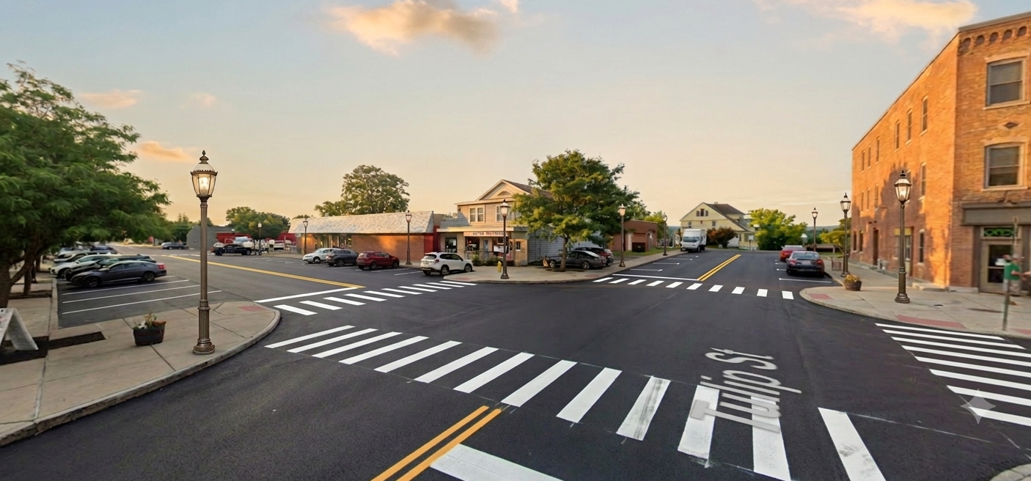
- Priority: High
Figure 9 Conceptual rendering illustrating First Street in downtown Liverpool with underground utilities, ornamental lighting, and enhanced streetscape improvements. This rendering is for visualization purposes only and represents a long-term vision. (Source: Google Street View and AI Conceptual Visualization: Gemini)
- Old Liverpool Road Sidewalk Extension
The Old Liverpool Road Sidewalk Extension project would extend the recently completed Old Liverpool Road Complete Streets improvements from Electronics Parkway into the Village of Liverpool, terminating at the gateway intersection of Oswego Street, Onondaga Lake Parkway, and 1st Street. While the Town’s Complete Streets project greatly improved safety and accessibility, it currently stops short of the Village, leaving a gap in pedestrian and bicycle connectivity. Extending the sidewalk and related enhancements would create a continuous multimodal corridor linking neighborhoods in the Town to the Village’s downtown and waterfront.
The extension will improve safety and accessibility for pedestrians and cyclists, encourage active transportation, and reduce reliance on automobiles for short trips. By connecting directly to the Village center and waterfront, it will strengthen ties between the Town and Village, support economic activity, and build on the success of the Town’s prior Complete Streets investments.
- Policies: 1, 2, 4, 5, 9, 18, 19, 20, 22, 41
- Lead Agency: Town of Salina
- Cooperating: Village of Liverpool; DOT
- Funding: DOS, NYSDOT, SS4A, Transportation Alternatives Program, NY Main Street
- Priority: Medium

- Transportation and Intersection Upgrades
This project focuses on improving the complex and unsafe intersection where Old Liverpool Road, Oswego Street, 1st Street, South Willow Street, and Onondaga Lake Parkway converge. Enhancements would not only address traffic safety and circulation concerns but also improve the primary park entrance to Onondaga Lake Park. As part of these upgrades, new wayfinding signage would be installed to guide drivers toward designated County parking lots, reducing congestion within the Village and helping to balance visitor demand with residential quality of life.
Upgrading this high-traffic intersection would improve safety for motorists, pedestrians, and cyclists while creating a more welcoming and efficient gateway into both the Village and Onondaga Lake Park. Enhanced wayfinding would help redirect non-local traffic away from neighborhood streets, encourage use of larger public parking areas, and strengthen connections between regional visitors and local amenities.
- Policies: 1, 2, 4, 5, 9, 18, 19, 20, 22, 25, 41
- Lead Agency: Village of Liverpool
- Cooperating: Town of Salina;
- Funding: DOS, NYSDOT, FHWA
- Priority: Low

- Old Liverpool Road Pedestrian Bridge
This project proposes constructing a pedestrian bridge along the CSX railroad right-of-way, using an existing easement that extends from Old Liverpool Road at the Electronics Parkway intersection to the Onondaga Lake Parkway. The bridge would create a safe, direct, and permanent connection between the Town of Salina’s neighborhoods and Onondaga Lake Park. Once in place, this connection would also link to the completed Loop-the-Lake Trail, strengthening regional trail networks and expanding non-motorized access to the waterfront.
The pedestrian bridge would eliminate a major physical barrier to the waterfront, improve safety for pedestrians and cyclists, and provide a continuous, direct route to Onondaga Lake Park and the regional trail system. By enhancing accessibility, the project supports recreational use, encourages alternative transportation, and helps integrate the waterfront more closely with surrounding neighborhoods.
Public feedback also identified interest in nearby multipurpose recreation and event space, including seasonal ice skating and field activities. The pedestrian bridge could improve access to these types of future amenities by strengthening the connection between neighborhoods, parking areas, Onondaga Lake Park, and the regional trail system.
- Policies: 1, 2, 4, 5, 9, 18, 19, 20, 22, 25, 41
- Lead Agency: Town of Salina
- Cooperating: Onondaga County; CSX (?)
- Funding: DOS, Bridge NY (NYSDOT), Parks and Trails Partnership Grant administered by OPRHP
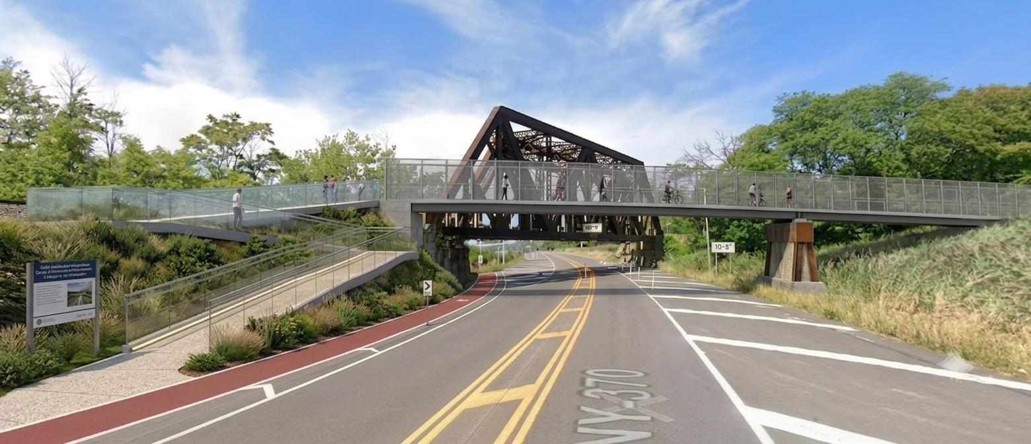
- Priority: High
Figure 10 Conceptual rendering illustrating a potential pedestrian bridge utilizing the existing CSX pedestrian easement to cross Onondaga Lake Parkway adjacent to the CSX railroad bridge, providing a connection between Old Liverpool Road, the Jesuit Well, Onondaga Lake Parkway, and the future Loop-the-Lake Trail. This rendering is for visualization purposes only and represents a long-term vision. (Source: Google Street View and AI Conceptual Visualization: Gemini)

- Duerr Park Waterfront Connection
This project envisions creating a pedestrian and bicycle connection from Duerr Park to the Onondaga Lake waterfront by following the Saw Mill Creek corridor. Establishing this link would require coordination with private property owners to secure easements, as well as a safe crossing over I-90 via the Route 370 bridge. Over time, this connection could extend to link with the proposed Cold Springs Neighborhood Waterfront Boardwalk Connection, forming part of a broader network of trails in the northern portion of the waterfront area.
The project would expand recreational opportunities by linking a major Town park to Onondaga Lake Park and the regional trail system, offering residents new options for walking, biking, and nature access. By following the Saw Mill Creek corridor, the trail could highlight natural features while connecting neighborhoods to the waterfront. If extended to Cold Springs, this connection would create a continuous non-motorized route between multiple neighborhoods and the lakefront, enhancing both community access and regional connectivity.
- Policies: 1, 4, 5, 9, 18, 19, 20, 25, 41
- Lead Agency: Town of Salina
- Cooperating: Onondaga County; private property owners
- Funding: DOS, NYSDOT, RTP administered by OPRHP, PTPP administered by OPRHP, SS4A
- Priority: Low

- Cold Springs Waterfront Connection
This project would establish a direct pedestrian and bicycle connection from the Cold Springs neighborhood to the Onondaga Lake waterfront via Cleveland Avenue. The proposed alignment would incorporate a boardwalk through the public wetlands, ensuring that access improvements are balanced with environmental protection. In addition to the waterfront connection, there is potential to create an internal neighborhood trail linking Cleveland Avenue to Walters Drive, enhancing local circulation. Because some of the land along the potential routes is privately owned, implementation will require easements or cooperative agreements with property owners.
The project would significantly expand public access to the waterfront for the Cold Springs neighborhood, which is currently limited and disconnected from Onondaga Lake Park. By providing a safe and environmentally sensitive boardwalk, residents could enjoy recreational opportunities while minimizing impacts to sensitive wetland habitat. The internal trail connection would also strengthen neighborhood walkability and offer non-motorized connections to the waterfront, improving quality of life and supporting active transportation.
- Policies: 1, 2, 4, 5, 9, 18, 19, 20, 22, 25, 41
- Lead Agency: Town of Salina
- Cooperating: Onondaga County; private property owners
- Funding: DOS, NYSDOT, SS4A, Transportation Alternatives Program, NY Main Street, PeopleForBikes Industry Community Grant, various grants administered by FHWA
- Priority: Medium
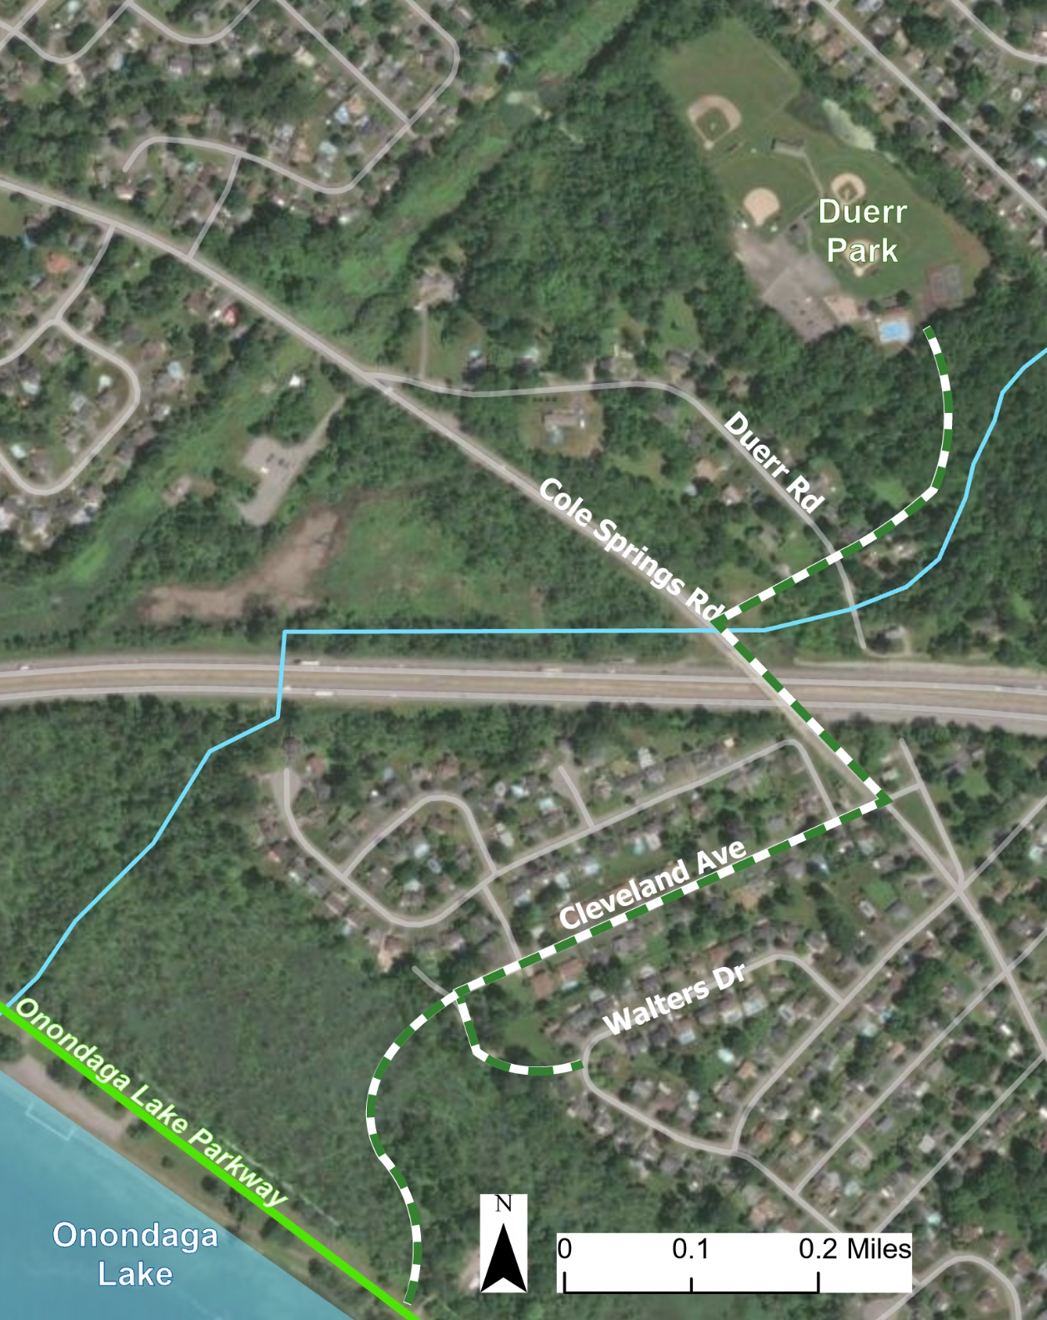
Figure 11 Conceptual trail map illustrating a potential trail connection between Duerr Park and the Cold Springs neighborhood, along with a proposed trail linking the neighborhood to the Onondaga Lake Parkway Trail / Restoration Way.

Cultural Heritage and Community Identity
Salina and Liverpool will celebrate and preserve the cultural and historical assets that define the community’s identity along the waterfront. By protecting historic sites, enhancing interpretive signage, and strengthening partnerships with local organizations, the Town and Village will honor their heritage while creating engaging experiences for residents and visitors. Investments in cultural recognition and community pride will ensure the waterfront reflects both its history and its ongoing role as a place of gathering and shared identity.
- Salina Town Hall Site Enhancements
The Town of Salina recently completed construction of a pavilion and scenic overlook of Onondaga Lake at Town Hall. This investment has proven to be highly successful, offering residents and visitors a welcoming gathering space with expansive waterfront views. Building on this success, the Town proposes to continue site improvements that enhance the functionality and appeal of this civic and community space. Future enhancements could include expanded seating areas, landscaping improvements, interpretive signage, and additional recreational or event-oriented amenities that encourage year-round use.
Expanding the Town Hall site as a community destination strengthens the connection between civic life and the waterfront. Additional improvements would increase opportunities for community gatherings, cultural programming, and passive recreation, while highlighting the Town’s commitment to enhancing public access to Onondaga Lake. The project reinforces the role of Town Hall as both a civic hub and a waterfront attraction, supporting the broader vision of the LWRP to create vibrant, accessible, and connected public spaces.
- Policies: 1, 5, 18, 19, 20, 25
- Lead Agency: Town of Salina
- Cooperating:
- Funding: DOS, ESD, Restore NY
- Priority: Low
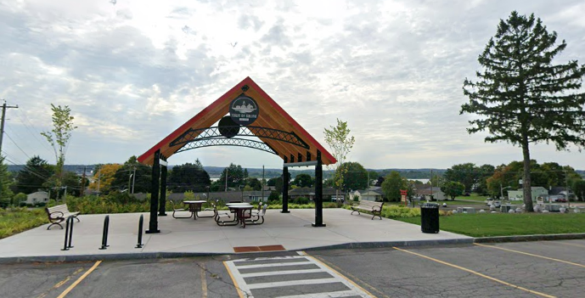

Figure 12 Pavilion located at the Salina Town Hall.
- Skä•noñh Great Law of Peace Center Enhancements
The Skä•noñh Great Law of Peace Center, located along the Onondaga Lake Parkway, is a significant cultural and educational resource that interprets the history, values, and living traditions of the Haudenosaunee. As a County-owned site operated in partnership with the Onondaga Historical Association (OHA), the Center serves as an important destination for residents, visitors, and school groups, offering exhibits, programming, and opportunities for cultural engagement. While the site is a valued asset within the Waterfront Revitalization Area, there are opportunities to expand its role as a year-round destination that integrates cultural interpretation, recreation, and environmental stewardship.
This project proposes a coordinated set of site improvements to better align the physical environment with the Center’s mission while enhancing the visitor experience and expanding programming opportunities. A key component of the project is the construction of a traditional Haudenosaunee longhouse, which would serve as a focal point for cultural interpretation, storytelling, demonstrations, and educational programming. This feature would help shift the site’s physical character to more accurately reflect Haudenosaunee history and living traditions.
Additional improvements include the rehabilitation, removal, or replacement of existing outbuildings that are currently in disrepair. These structures will be replaced with new facilities that better support current and future programming needs, including a small accessory building for seasonal equipment rentals such as snowshoes, storage, or visitor services. The project would also explore reconfiguring portions of the site to create flexible outdoor spaces that can accommodate events, cultural demonstrations, educational programming, and small-scale vendor opportunities.
The project also includes the development of a nature-based trail system throughout the property. These trails would support passive, year-round recreation such as walking and snowshoeing while incorporating interpretive signage focused on native plant species, including those with traditional medicinal and edible uses. Native plantings and ecological restoration strategies would be integrated into the trail design to reinforce environmental stewardship and reflect the Haudenosaunee relationship with the natural world.
Given the site’s proximity to active railroad infrastructure, the project will also evaluate and incorporate appropriate safety measures, which may include improved signage, barriers, or reconfigured circulation routes to ensure safe access for visitors.
Public feedback emphasized the importance of dual-language signage and interpretation that more fully reflects Haudenosaunee culture, language, and history. Site improvements should include culturally appropriate wayfinding and interpretive signage developed in coordination with OHA, Onondaga County, and Haudenosaunee representatives.
- Policies: 1, 4, 5, 7, 8, 17, 18, 19, 20, 22, 23, 25, 42, 44
- Lead Agency: Onondaga Historical Association
- Cooperating: Onondaga County; Town of Salina; Canal Corporation
- Funding: DOS, OPRHP (EPF, MRP), NYSCA, National Endowment for the Humanities, Environmental Education Grants (DEC)
- Priority: High

- Jesuit Well Heritage Site
The Jesuit Well, also referred to locally as the Le Moyne Well, is a historic heritage site located off Old Liverpool Road in a wooded area between the road and Onondaga Lake Parkway. The site, which commemorates the arrival of French Jesuit missionaries led by Father Simon Le Moyne in 1654, is an important cultural marker in the history of European–Haudenosaunee relations in Central New York. Currently, the well is difficult to access, situated behind the Residences at Le Moyne Manor, and lacks the visibility and interpretation it deserves.
This project proposes restoring and improving public access to the site, which sits partially on Onondaga County property and partially on the private lands of the Residences at Le Moyne Manor. Successful implementation would require coordination and partnership between Onondaga County, the Onondaga Historical Association (OHA), and the Residences at Le Moyne Manor. Improvements may include site restoration, interpretive signage, pathway access, and landscape enhancements to highlight the well as both a historic and cultural destination.
Enhancing access to and interpretation of the Jesuit Well would preserve and promote an underrecognized heritage resource of regional and national significance. Restoring the site and making it publicly accessible would provide educational and cultural value, create a destination within the Salina–Liverpool waterfront area, and support heritage tourism. The project would also strengthen partnerships among public, nonprofit, and private stakeholders while celebrating the diverse history of Onondaga Lake and its role in shaping the region. Public feedback reinforced the importance of acknowledging the Jesuit Well as part of the broader cultural and historical story of the waterfront.
- Policies: 1, 23
- Lead Agency: Onondaga Historical Association
- Cooperating: Onondaga County; Town of Salina
- Funding: DOS, OPRHP, SHPO
- Priority: Low

Environmental Stewardship and Resilience
Salina and Liverpool will protect and restore the natural systems of Onondaga Lake while building resilience to future environmental challenges. By improving water quality, enhancing habitats, and managing stormwater more effectively, the Town and Village will safeguard ecological health and expand opportunities for residents to connect with nature. These efforts will strengthen the lakefront as both an environmental resource and a community asset for generations to come.
- Stormwater Infrastructure Improvements
Onondaga Lake and its tributaries remain vulnerable to stormwater runoff and sewage overflows during heavy rain events, which impact both water quality and public access. The Town of Salina has identified a need to improve its stormwater infrastructure to reduce localized flooding and prevent untreated discharges into the lake. One area of particular concern is the Galeville neighborhood, which has experienced recurrent flooding and stormwater management challenges.
This project would involve evaluating the existing stormwater system, identifying priority upgrades, and implementing infrastructure improvements. Potential measures may include separated storm and sanitary sewers, green infrastructure installations (rain gardens, bioswales, permeable pavement), culvert and drainage system upgrades, and improved outfall management. These improvements would be designed to reduce pollutant loads, increase resilience against heavy rainfall, and protect lake water quality.
- Policies: 5, 8, 12, 17, 25, 30, 33
- Lead Agency: Town of Salina;
- Cooperating: Village of Liverpool; Onondaga County
- Funding: DOS, DEC (CSC, WQIP, etc.), GIGP, GRG, WIIA
- Priority: Medium

- Habitat Appreciation Areas
The Onondaga Lake Parkway Trail (part of the regional Loop-the-Lake Trail system) provides a unique opportunity to integrate ecological education and habitat restoration directly into the public recreation experience. This project proposes the creation of designated “habitat appreciation areas” along the trail, featuring pollinator gardens, native plantings, and interpretive signage to highlight the importance of biodiversity, migratory bird habitat, and shoreline ecosystems. These areas would be overseen and maintained by Onondaga County, with support from the Town of Salina and Village of Liverpool.
By incorporating native plant species and pollinator-friendly landscaping, these sites would enhance ecological resilience, reduce invasive species pressures, and create visually engaging spaces along the trail. The interpretive signage would connect visitors with the lake’s natural heritage and foster a stronger sense of stewardship.
The establishment of habitat appreciation areas would improve environmental quality while enriching the recreational experience for trail users. These spaces would provide critical habitat for pollinators and wildlife, contribute to shoreline stabilization, and enhance the scenic character of the Onondaga Lake waterfront. By combining ecological restoration with public engagement, the project would strengthen the link between recreation, education, and environmental stewardship.
- Policies: 1, 4, 7, 8, 17, 18, 19, 25, 42, 44
- Lead Agency: Onondaga County
- Cooperating: Village of Liverpool; Town of Salina
- Funding: DOS, NYSDEC, EPF, NY Community Trust, Land Trust alliance, OPRHP
- Priority: Medium

Land Use and Development
Salina and Liverpool will guide land use decisions that balance growth with community character, ensuring development strengthens the Village, Town, and waterfront as interconnected destinations. By promoting context-sensitive, mixed-use redevelopment and coordinating planning for strategic sites, the Town and Village will create spaces that are vibrant, accessible, and aligned with community needs. Land use policies will support new amenities while carefully considering housing scale, traffic, and neighborhood impacts, protecting quality of life while enhancing the waterfront’s role as a regional draw.
- Waterfront Mixed-Use Development
Encouraging strategic mixed-use development near the waterfront and existing parking areas presents an opportunity to create vibrant, pedestrian-oriented spaces that complement the Village’s historic character and the Town’s community assets. The intent of this project is to introduce development that blends residential, commercial, cultural, and recreational uses in ways that activate the waterfront year-round. By concentrating mixed-use development near established access points and parking facilities, the project supports walkability, encourages economic activity, and strengthens the connection between the waterfront and adjacent business districts. These developments could feature ground-floor retail, dining, or cultural spaces with upper-level residential or office uses, contributing to a lively, human-scale environment. Aligning with the community’s vision, such development would enhance the appeal of the waterfront as both a local gathering place and a regional destination, while ensuring new construction is context-sensitive, appropriately scaled, and supportive of multimodal access.
This project would evaluate opportunities for context-sensitive, mixed-use development near the waterfront and along Lake Drive, while carefully considering floodplain conditions, infrastructure capacity, parking, neighborhood impacts, and consistency with Village character. Any future development would require additional planning, environmental review, flood-resilient design, and coordination with applicable local, state, and federal permitting requirements.
- Policies: 1, 5, 19, 20, 25, 41, 42, 43
- Lead Agency: Village of Liverpool
- Cooperating: Town of Salina; Onondaga County
- Funding: DOS, Empire State Development, Restore NY
- Priority: Medium

- Basin Block Coordinated Planning
The Basin Block is a prominent area of the Village, anchoring the southern gateway to Onondaga Lake Park and the eastern entrance to the Village’s downtown core along 1st Street. It contains a mix of legacy businesses, vacant parcels, and underutilized buildings, including the Gormel properties, which present a prime opportunity for redevelopment. This project calls for coordinated planning of the Basin Block to ensure that future development is strategic, cohesive, and reflective of community priorities. By planning comprehensively, the Village can balance redevelopment opportunities with the need to maintain its small-scale, pedestrian-friendly character, while also leveraging the block’s proximity to the waterfront and its role as a key connector between the park and downtown. Coordinated planning will help guide reinvestment, encourage appropriate mixed-use development, and create a unified vision for the Basin Block that strengthens its identity as both a community hub and a gateway to the waterfront.
- Policies: 1, 5, 22, 25
- Lead Agency: Village of Liverpool
- Cooperating: Town of Salina; Onondaga County
- Funding: DOS, ESD, Restore NY, NY Main Street, CDBG
- Priority: Low

