SECTION 1: Overview of the Local Waterfront Revitalization Area Program

Town of Salina / Village of Liverpool Waterfront Revitalization Areas
This section of the LWRP describes the proposed Town of Salina waterfront revitalization area (WRA) and the proposed Village of Liverpool waterfront revitalization area. The boundaries of each WRA are described below. The WRA is strategically designed to connect neighborhoods to the waterfront, promoting a cohesive community vision that integrates both economic and recreational opportunities.
The large inland area includes key commercial and residential zones that are intrinsically linked to the waterfront. By extending the boundary to include neighborhoods as well as underutilized parcels with redevelopment potential and areas with historic significance, the Town and Village aim to leverage these assets for broader economic revitalization. Additionally, this approach ensures that inland areas, which have a direct influence on the waterfront, are managed in a way that aligns with the LWRP's overall goals, including protecting natural resources and enhancing the quality of life for residents.

Proposed Town of Salina Waterfront Revitalization Area
The proposed Town of Salina Waterfront Revitalization Area (WRA) encompasses freshwater wetlands, designated impaired waterbodies, a natural community, rare plants and animals, Audubon Important Bird Area, State listed remediation sites, segments of tributaries to Onondaga Lake and their floodways, etc.
- Overall the Town of Salina WRA captures:
  - Portions of commercial land uses along Old Liverpool Road to fuel economic investment;
  - Sections of neighborhoods to the north of the Onondaga Lake Parkway to strengthen community ties to the waterfront;
  - Industrial land adjacent to Ley Creek

The area of the proposed WRA is 4,681 acres, including approximately 4.32 miles of shoreline along Onondaga Lake, 2.37 miles of shoreline along Seneca River and 2.69 miles of shoreline along Ley Creek.
The Waterfront Revitalization Area within the town of Salina, illustrated by the continuous red line in Figure 1: Town of Salina WRA and HMA Boundaries beginning at a southeastern corner of the town’s municipal boundary,
- Then, in a northwesterly direction, the boundary follows the town limits approximately 4.7 miles at the approximate midline of Onondaga Lake until the shoreline reaches the Seneca River;
- Thence in a northeasterly direction, the boundary follows the town limits approximately 1.6 miles until it reaches the northernmost corner of the town’s municipal boundary;
- Thence in a southeasterly direction, the boundary travels approximately 2.21 miles along the town’s municipal boundary;
- Thence in a southern direction, travels approximately 595 feet along Donald Place until reaching the Village of Liverpool municipal boundary;
- Thence, in a southwesterly direction, the boundary follows the village’s western municipal boundary until reaching the shoreline of Onondaga Lake;
- Thence, in a southeasterly direction, the boundary follows the village’s shoreline until reaching the southeastern point of the village’s boundary;
- Thence, in a northeasterly direction, the boundary follows the village’s eastern municipal boundary until reaching the easternmost corner of the village;
- Thence, in a northwesterly direction, the boundary follows the village’s eastern municipal boundary until reaching Tulip Street;
- Thence in a northerly direction, the boundary travels approximately 680 ft until reaching the town of Salina municipal boundary;
- Thence in a southeasterly direction, the boundary travels approximately 1 mile until intersecting with the northern Right-of-Way of I-90;
- Thence, in a northeasterly direction, the boundary travels along the northern Right-of-Way of I-90 for approximately 4.2 miles, crossing to the eastern Right-of-Way of Townline Road;
- Thence in a southern direction, the boundary travels along for approximately 900 feet;
- Thence in an easterly direction, the boundary travels along the center Right-of-Way of Factory Ave approximately 1.7 miles until reaching the intersection of Factory Ave and Brewerton Road/Route 11;
- Thence in a southwesterly direction, the boundary travels along the center Right-of-Way of Brewerton Road approximately 570 feet
- Thence, in a southwesterly direction, the boundary travels for approximately 1,000ft along the northern parcel boundary of 1401 Brewerton Rd until it intersects with Ley Creek;
- Thence, in a southwesterly direction, the boundary travels approximately 2,400ft along Ley Creek until reaching the town limits;
- Thence, in a southwesterly direction, the boundary travels approximately 3,800ft along the town limit;
- Thence, in a northwesterly direction, the boundary follows the town limits approximately 2,070ft;
- Thence, in a southwesterly direction, the boundary follows the town limits until it reaches the starting point.
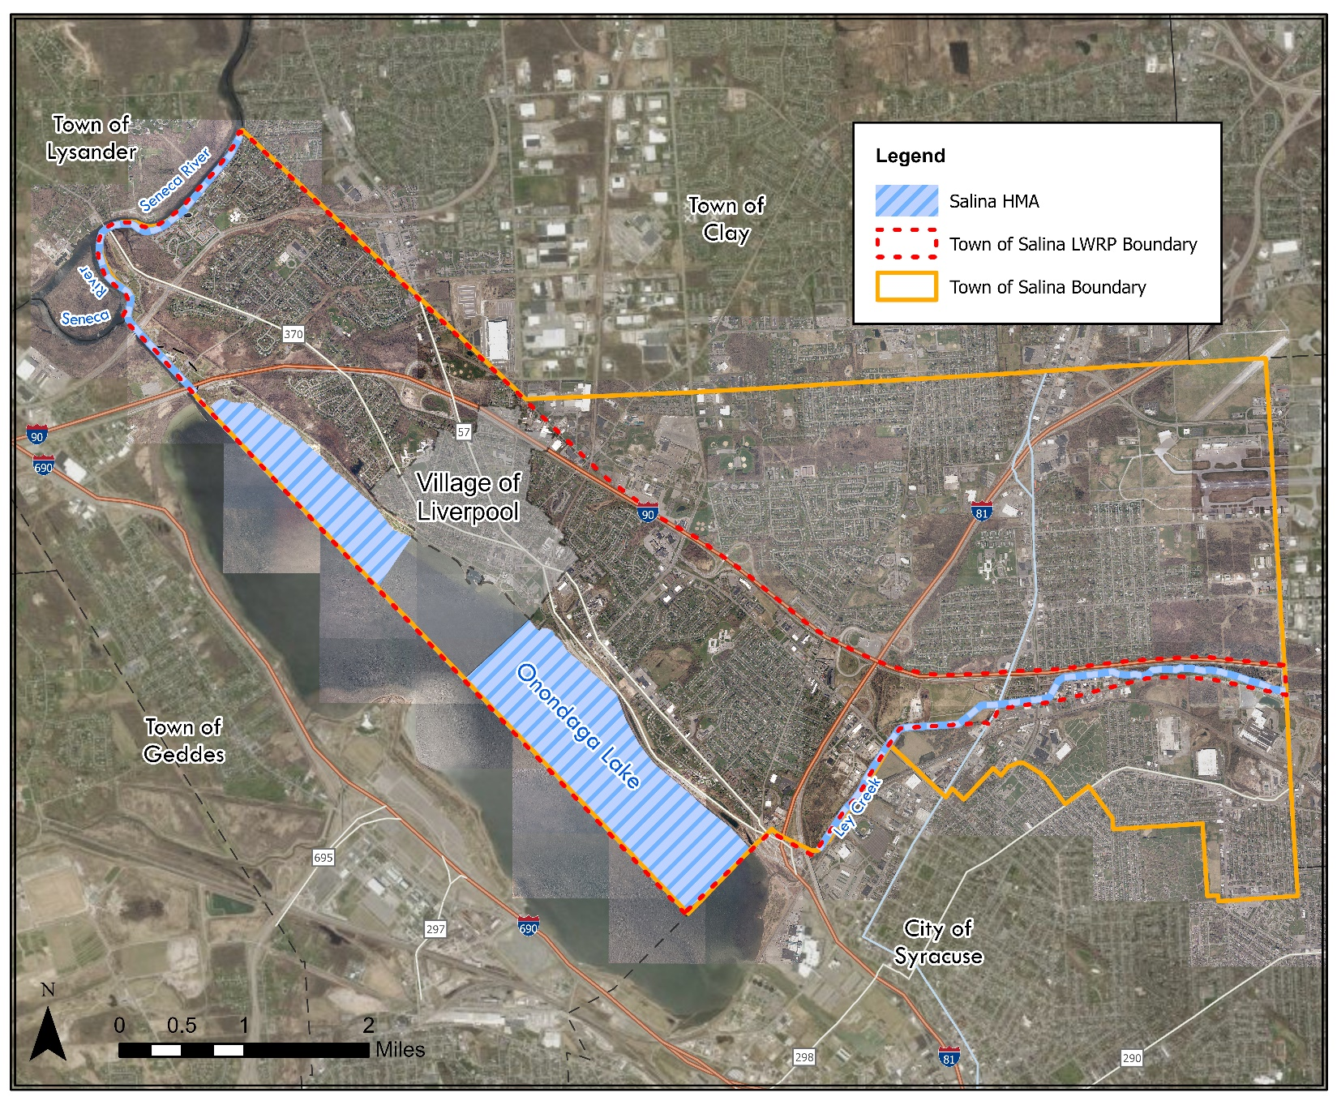
Ley Creek Start Point
HMA Start Point
WRA Start Point
Figure 1: Town of Salina WRA and HMA Boundaries

The waterside boundary of the Salina waterfront revitalization area, or the Salina Harbor Management Area (HMA), is illustrated above in Figure 1 by the continuous purple line beginning at the northernmost corner of the municipal boundary at the waterside boundary of the Seneca River;
- Thence in a southwesterly direction, the boundary travels approximately 1.7 miles until reaching the Lake Outlet;
- Thence in a southeasterly direction, the boundary travels approximately 4,000 feet until reaching the Onondaga Lake;
- Thence in a southeasterly direction, the boundary travels along the town’s shoreline of Onondaga Lake for approximately 1.5 miles until reaching the village’s shoreline;
- Thence in a southwesterly direction, the boundary travels approximately 1,300 feet into the lake until it reaches the town’s limits;
- Thence, in a southeasterly direction, the boundary travels approximately 4,400 feet;
- Thence, in a northeasterly direction, the boundary travels approximately 1,480 feet until reaching the shoreline;
- Thence, in a southeasterly direction, the boundary travels approximately 1.9 miles along the shoreline until reaching Salina’s southern municipal boundary;
- Thence in a southwesterly direction, the boundary travels 1,480 miles along the town’s limits into the lake;
- Thence, in a northwesterly direction, the boundary travels 4 miles until reaching the lake outlet
- Thence, the boundary follows the shoreline southwesterly for approximately 4 miles until reaching the town’s southern boundary;
- Thence, the boundary follows the Salina River northeasterly until it reaches the starting point.
The Lay Creek portion of the HMA begins from the starting from the eastern municipal boundary;
- Thence, in a western direction, it travels approximately 2.35 miles
- Thence, in a northwesterly direction, it travels approximately 3,900 feet, ending after reaching the southern town municipal boundary.

Proposed Village of Liverpool Waterfront Revitalization Area
The proposed Village of Liverpool Waterfront Revitalization Area (WRA) encompasses designated impaired waterbodies, a county park community, marina and commercial areas.
The Waterfront Revitalization Area within the Village of Liverpool, illustrated by the continuous red line in Figure 1: Salina WRA Boundary beginning at a southeastern corner of the Village’s municipal boundary,
- Thence in a northeasterly direction, the boundary follows the village municipal boundary approximately 2,400 ft;
- Thence in a northwesterly direction, the boundary follows the village municipal boundary approximately 820 ft;
- Thence in a northeasterly direction, the boundary follows the village municipal boundary approximately 320 ft;
- Thence in a northwesterly direction, the boundary follows the village municipal boundary approximately 680 ft until it intersects with 4th street;
- Thence, in a northwesterly direction, the boundary travels approximately 990 ft along 4th street until it intersects with Tamarack Street;
- Thence in a northern direction, the boundary travels approximately 980 ft along Tamarack Street;
- Thence in an easterly direction, the boundary follows the village municipal boundary approximately 45 ft;
- Thence in a northerly direction, the boundary follows the village municipal boundary approximately 190 ft;
- Thence in n westerly direction, the boundary follows the village municipal boundary approximately 85 ft;
- Thence in a northern direction, the boundary follows the village municipal boundary approximately 450 ft;
- Thence in an easterly direction, the boundary follows the village municipal boundary approximately 490 ft;
- Thence in a northeasterly direction, the boundary follows the village municipal boundary approximately 560 ft;
- Thence in a westerly direction, the boundary follows the village municipal boundary approximately 880 ft;
- Thence in a northerly direction, the boundary follows the village municipal boundary approximately 180 ft;
- Thence in a westerly direction, the boundary follows the village municipal boundary approximately 230 ft until it intersects with Tulip St;
- Thence in a northerly direction, the boundary travels along Tulip Street approximately 520 ft;
- Thence in a westerly direction, the boundary follows the village municipal boundary approximately 200 ft;
- Thence in a northerly direction, the boundary follows the village municipal boundary approximately 70 ft;
- Thence in a westerly direction, the boundary follows the village municipal boundary approximately 1,100 ft;
- Thence in a southernly direction, the boundary follows the village municipal boundary approximately 820 ft;
- Thence in a southwesterly direction, the boundary follows the village municipal boundary approximately 460 ft until reaching the intersection of Meyers Road and Oswego Street;
- Thence in a northwesterly direction, the boundary follows Meyers Road approximately 760 ft;
- Thence in a southwesterly direction, the boundary follows the village municipal boundary approximately 150 ft;
- Thence in an easterly direction, the boundary follows the village municipal boundary approximately 35 ft;
- Thence in a southwesterly direction, the boundary follows the village municipal boundary approximately 550 ft
- Thence in a northwesterly direction, the boundary follows the village municipal boundary approximately 200 ft
- Thence, in a southwesterly direction, the boundary follows the village municipal boundary approximately 1,300 ft until it intersects with Cold Spring Road;
- Thence, in a northwesterly direction, the boundary travels along Cold Spring Road approximately 400 ft;
- Thence in a southwesterly direction, the boundary follows the village municipal boundary approximately 980 ft;
- Thence in a southeasterly direction, the boundary follows the village municipal boundary approximately 1,900 ft;
- Thence in a northerly direction, the boundary follows the village municipal boundary approximately 250fr until it reaches the shoreline;
- Thence, in a southeasterly direction, the boundary travels along the shoreline approximately 5,000 ft until it reaches the starting point.
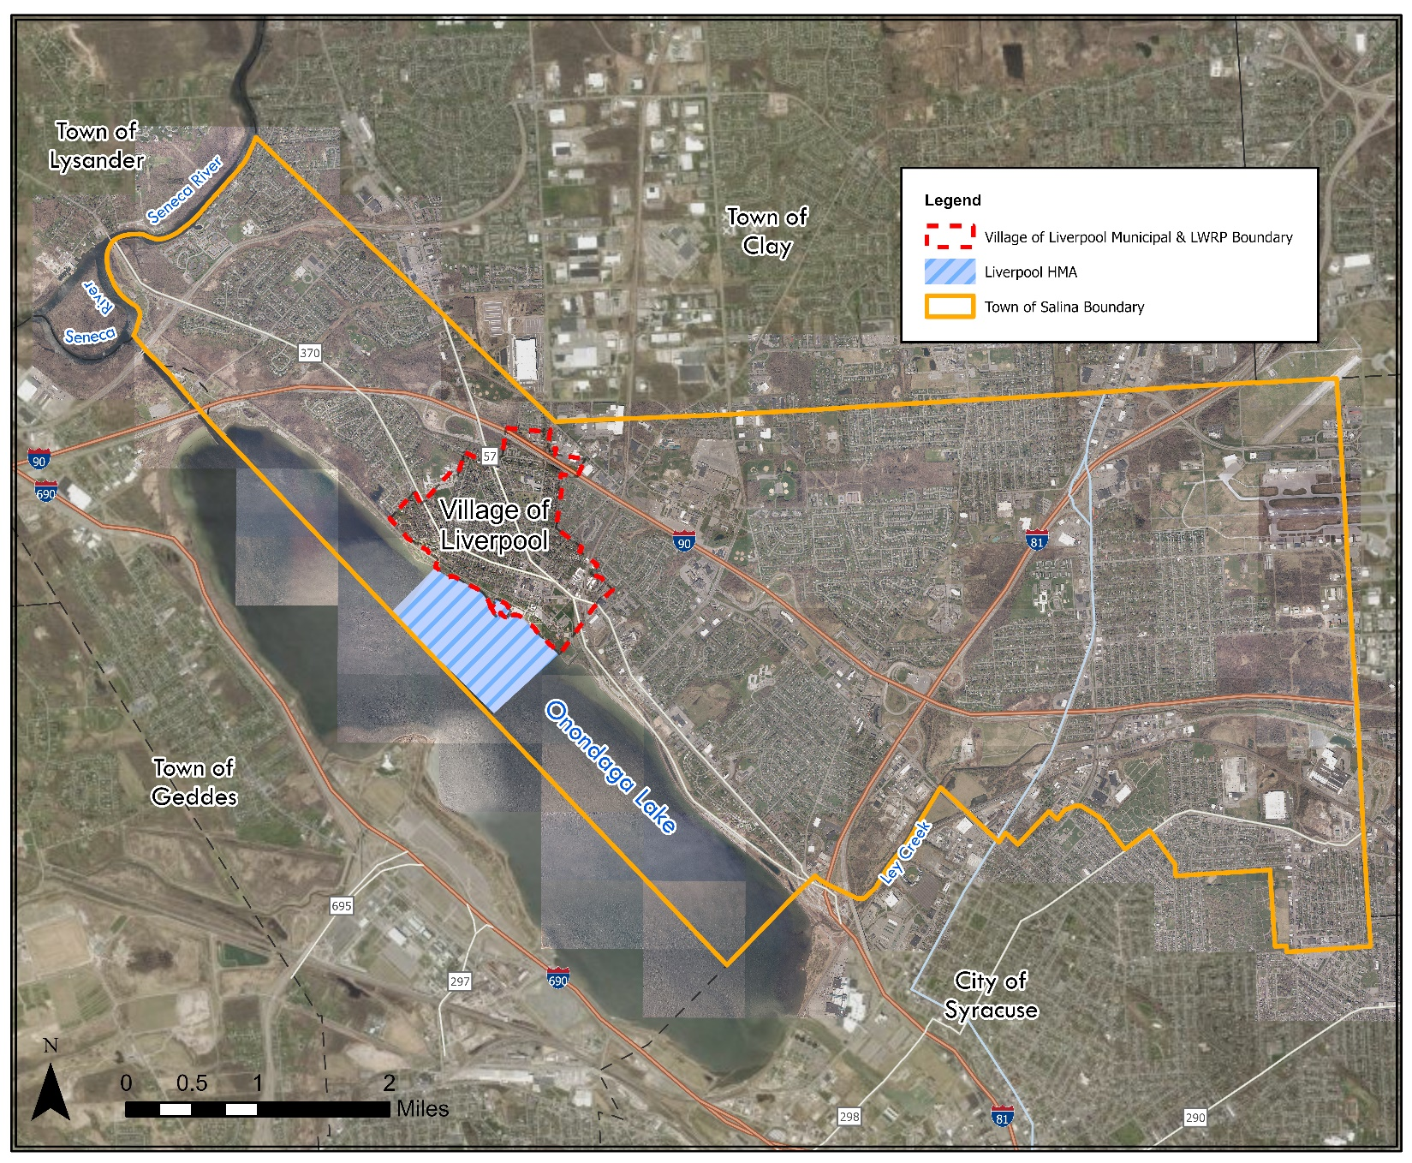
WRA and HMA Starting Point
Figure 2 Village of Liverpool WRA and HMA Boundaries

